Care Homes Strategy for Infection Prevention & Control of Covid-19 Based on Clear Delineation of Risk Zones

Version date: 12th December 2020

Written by:
Eric Fewster, BA, MSc, C.WEM, MCIWEM, CEnv, Independent Water & Environmental Manager, Salford, UK
With contributions / review from:
Dr David R Tomlinson, BM, BSc, MD, University Hospitals Plymouth NHS Trust, Plymouth, UK
Jean-François Fesselet, MSc, WatSan Unit Coordinator, Médécins Sans Frontières, Amsterdam, The Netherlands
Dr Sarah House, BEng, DIS, MSc, D.Litt, CEng, MICE, C.WEM, FCIWEM, Independent Water Sanitation & Hygiene (WASH) Consultant / Public Health Engineer, Leicester, UK
Dr Michaël R Laurent, MD, PhD, Geriatrician, Imelda Hospital, Bonheiden, Belgium
Adelina Comas-Herrera, MSc, Assistant Professorial Research Fellow, Care Policy & Evaluation Research Centre (CPEC), London School of Economics & Political Science, UK, Editor of LTCcovid.org
Dr Muh-Yong Yen, MD, Director, Department of Diseases Control & Prevention, Taipei City Hospital, Taiwan
Dr Jonathan Schwartz, PhD, State University of New York at New Paltz, USA
Alison Criado-Perez, RN, DTN, Rutland, UK
Christopher J Peskett, BA, RN, CTN, Norwich, UK
Alex Mikszewski, The City University of New York Building Performance Lab, New York, USA
Giorgio Buonanno, PhD, Full professor of Applied Thermodynamics, University of Cassino and Southern Lazio, Italy
Maria Betânia Silva, Law Bachelor (LLB, Brazil), MSc, Oxford, UK
Anita Astle, MBE, Managing Director, Wren Hall Nursing Home, Selston, UK
Shrien Dewani, BSc, ACA, Director, Evolve Care Group, Bristol, UK
Eve Carder, RN, Clinical Director, Evolve Care Group, Bristol, UK
Liz Jones, Policy Director, National Care Forum, Coventry, UK
Dr Lucy Owen, RSci, MRSB, Postdoctoral Researcher, Infectious Disease Research Group, De Montfort University, Leicester, UK
Dr Katie Laird, CBiol, FRSB, FHEA, Reader in Microbiology, Associate Professor of Research, Head of the Infectious Disease Research Group, De Montfort University, Leicester, UK
Jackie Hook, CChem MRSC, Technical Support Chemist, JLA Limited, Ripponden, UK

The author and reviewers collectively have a mix of experience from medicine/health, care and nursing homes, water/sanitation/hygiene, outbreak infection prevention & control (specifically from Ebola, SARS, Cholera, Lassa Haemorrhagic Fever, Tuberculosis and Diphtheria outbreaks), emergency response and ventilation of buildings.
Disclaimer: note that contributions / review by authors or contributors does not mean endorsement by the institution they work for.
If anyone has found this document useful and is using part of it in some capacity, we would appreciate to hear from you. For any questions, comments or suggested changes, please contact:
Eric Fewster, ericfewster@bushproof.com, +44 7814 788 846

This document continues to be subject to modification, given new evidence and information that comes in.
Revisions:
Date | Section | Revision
17th April 2020 |  | Original online
18th April 2020 | 2 | Clarity added on symptoms, and unreliability of symptoms-based screening
18th April 2020 | 11, 18 (now 19) | Clarification that 0.1% and 1,000 ppm are the same
20th April 2020 | 11 | Removed ‘other considerations’ section on copper tape
20th April 2020 | Title page | Added qualifications
20th April 2020 | 18 (now 19) | Clarification on accuracy required for weighing out chlorine
21st April 2020 | 1 | Added up to date paper on zoning by Schwartz et al (2020) and Yen et al (2020), also added text around less-than-ideal conditions of promoting IPC in care homes using our methodology, added ‘other options’ section in
21st April 2020 | 4, 9 | Expanded on staff allocation info, and info on masks for staff
21st April 2020 | 15 | Added a bit on observing hygiene in staff zone
22nd April 2020 | 15 | Added PHE and CDC guidance on return to work, with links
29th April 2020 | 2 | Modified & added layout variations, added text on layout options, added info on long-shedders
29th April 2020 | 4 | Modified staff allocation text
29th April 2020 | 9, 12, 16 | Some modifications to recommendations around vacuum cleaning
29th April 2020 | Title page | Added contributors
11th May 2020 | 2 | Added symptom to list (loss of taste), reworded part on asymptomatic transmission, rejigged colour code in layout 1
11th May 2020 | 19 (now 20) | Added new section to explain asymptomatic / pre-symptomatic transmission along with references
11th May 2020 | 6, 7 | Added reference to GPs or nurses as being possible visitors
11th May 2020 | 7 | Reworded section on isolation looking at pragmatic approach in longer term, added part on dementia, added details on elevators
11th May 2020 | 9 | Added link to facial hair and masks, info on re-use of FFP2/N95 masks, also training vid for PPE donning and doffing
11th May 2020 | 11 | Added rinse step before chlorination, noted not to store chlorine in basements
11th May 2020 | 14 | Link to signage zip file
11th May 2020 | 16 | Modification to advice for fans during heatwaves
11th May 2020 | 18 (now 19) | Underlining of fact to add chlorine to water, not the other way around
11th May 2020 | 12 | Removed part about segregating red/amber and green waste externally
1st June 2020 | Title page | Added contributors
1st June 2020 | 1 | Added reference to barrier nursing, second webinar link, link to UK government guidance changed to refer to our mapping document, new WHO reference added, added need for outbreak pre-plan
1st June 2020 | 2 | Qualified the part about testing, suggesting 2 tests to confirm if negative
1st June 2020 | 5 | Added part about sharing communal items like books
1st June 2020 | 6 | Added entrance info if making visitor room
1st June 2020 | 7 | Added for those isolating to have dedicated commodes & opportunities for bathing, also giving residents the option to wear masks if they want, plus idea for visitor room
1st June 2020 | 9 | Added part about laminated portraits, use of masks by staff when away from the care home and option for residents to wear masks if they wish, and a note on FFP2/N95 re-use.
1st June 2020 | 10 | Made a note about dishwashers
1st June 2020 | 12 | Added part about clinical waste bags, tissues, paper towels, and leaving some waste for 72 hours if no clinical waste stream
1st June 2020 | 15 | Added part about loss of smell/taste, and wearing masks
1st June 2020 | 16 | Modified section title to be clear it was about aerosols, added advice for residents on sneezing/coughing, added carpet sweepers as option, mention on mask type for cleaners using vacuum cleaners
1st June 2020 | 17 (now 18) | Modified
1st June 2020 | 19 (now 20) | Added second webinar link
29th June 2020 | 3 | Added part about washing soiled hands with soap & water
29th June 2020 | 9 | Added info for masks with exhalation valves, modified part on research / evidence for masks, modified info & order of text around wearing masks and added fit/seal test info, added part on labelling and disposing of re-used masks
29th June 2020 | 11, 18 (now 19) | Removed reference to combined detergent-disinfectant products
29th June 2020 | 11 | Added part about QACs
29th June 2020 | 19 (now 20) | Added link to evidence base, added one reference in table
14th October 2020 | 2 | Correction of mistake on layout 1 (green residents room should be >14 days), added skin rash as symptom.
14th October 2020 | 17, 21 | New ventilation chapter and annex, subsequent chapters renumbered including references to them
14th October 2020 | 11 | Modified text around non-chlorine disinfectants.
16th October 2020 | 1 | Moved position of ‘fundamental aspects’ box, added Buonanno paper, reworded ‘preferred options’ part to include talk about primary barriers and testing options
16th October 2020 | 7 | Modified part about visitors and internal social interaction, also references on dementia
23rd November 2020 | 4 | Removed part on total shielding – is covered in section 1
23rd November 2020 | 7 | Revamped strategies for those with dementia, added link to our supplementary document reviewing guidance for caring for those with disability, added recommendation on enabling visiting with use of lateral flow rapid tests, modified part on sharing bedrooms.
23rd November 2020 | 8 | Added part on using thermal or low temperature chemical disinfection cycles
23rd November 2020 | 9 | Updated PHE link on PPE and paragraph above the PPE table, also table on re-use of PPE updated (to take account of thermal and low temperature chemical disinfection)
23rd November 2020 | 13 | Laundry section completely re-written
23rd November 2020 | 11 | Removed ‘if possible’ when talking about cleaning surfaces 2x per day, modified paragraph talking about the EN14476 standard, added bit about disinfecting mop heads
1st December 2020 | 2 | Added photophobia / eye pain to symptom list
1st December 2020 | 15 | Updated link and flow charts for staff return to work (symptomatic and asymptomatic cases), and consequently deleted CDC reference.
1st December 2020 | 18 | Simplified PHE reporting section to not talk about testing to prove infection ended
9th December 2020 | Title page | New contributors
9th December 2020 | 1 | Updated recommendation on use of certain lateral flow tests as primary barrier, added to box about planning for outbreaks
9th December 2020 | 2 | Removed recommendation to carry out 2 more tests after 14 days since positive test, added part on the usefulness of fire zones to inform IPC zones
9th December 2020 | 15 | Added part on having staff break plans, since this has been a time/area for virus transmission in care homes experience
12th December 2020 | 3 | Expanded part/rationale about gloves-on hand hygiene with alternative stated (i.e. change of gloves)

Contents
1. Introduction 7
2. Delineation of zones 13
3. Hand hygiene 18
4. Staff allocation & rotation in relation to zones 20
5. Use of equipment 20
6. Entrances: staff & resident flow 21
7. Isolation / quarantine / communal living / visitors 22
Room layout & sharing arrangements 22
Isolation & quarantine for when there are confirmed cases in the home 22
Internal social interaction & visitors for when there are no confirmed cases in the home 23
For residents with dementia and those experiencing emotional distress 25
8. Staff clothes from home / showering 26
9. Personal Protective Equipment (PPE) 26
Recommended PPE 27
Some notes on masks in general 29
Fit and seal tests for FFP2 / FFP3 / N95 respirators 30
Re-use of PPE 31
Donning & doffing 32
10. Food preparation / dishwashing 33
11. Chlorination / disinfection of items & cleaning of surfaces 33
PPE disinfection 34
Dishes 34
Surfaces 34
Notes on chlorine preparation 35
12. Waste 35
13. Laundry 36
Personal Protective Equipment 36
Handling Infectious Linen 36
Processing Infectious Linen 36
Transporting Infectious Linen 36
Laundering of Infectious Linen 36
Staff Uniforms 37
14. Signage 37
15. Staff health 38
16. Residents’ rooms & aerosols 40
17. Ventilation 40
Natural ventilation vs mechanical ventilation & air filtration 41
Overview of practical options in the short-term 42
Deciding on an MVHR and/or HEPA air filtration units for your context 44
Negative pressure room for infected residents 44
18. PHE reporting 45
19. Annex: Chlorine solution preparation 46
Safety 46
Types of chlorine 46
Procedure 46
20. Annex: Asymptomatic / pre-symptomatic transmission in care homes 48
21. Annex: Manual procedure to size a MVHR and / or HEPA air filtration unit 54

- Introduction
Rationale for needing this document
Some people with a nursing background will be familiar with the two concepts of source isolation (barrier nursing) and protective isolation (reverse barrier nursing). The general UK Government guidance also uses the terms Standard IPC (SIPC) procedures, which are the basic everyday procedures for IPC, and Transmission Based Precautions (TBPs), which are additional procedures for outbreak situations. This strategy aligns with these concepts, but adds a few specific additional barriers for COVID-19, that were currently missing or not clear from the UK government IPC guidance.
There are now two webinars available online that explain the rationale for this document and its key contents:
- An introduction to asymptomatic transmission and overview of the strategy document, recorded on 23rd April: https://youtu.be/QNN9iTnnRH0.
- A review of asymptomatic / pre-symptomatic transmission, recorded on 25th May: https://www.youtube.com/watch?v=kbTifRj7rg4.
This strategy incorporates as much current UK government guidance as possible, while remaining consistent. In May, we had undertaken a mapping of existing guidance in order to understand the strengths and gaps, and to show how it relates to our strategy and the rationale for where it differs:
Mapping of Government guidance for IPC for COVID-19 in care homes:
https://www.bushproof.com/wp-content/uploads/2020/05/Mapping-Govt-IPC-strategies-for-COVID-19-in-care-homes.pdf
Our care homes strategy is based around a fundamental understanding of asymptomatic / pre-symptomatic transmission as a major contributor to the spread of COVID-19. Because of that, we stress strongly the importance of clear delineation of risk zones throughout the entire building, in order to reduce cross-contamination including from asymptomatic residents to whom ‘normal care’ might otherwise be given.
Fundamental aspects of Infection Prevention & Control in care homes settings
- Understanding that asymptomatic / pre-symptomatic transmission is a major contributor to the spread of Covid-19 in care homes, where the source of this transmission comes from outside (mostly via staff and returning residents from hospital, but also visitors)
- Clear delineation of zones of risk for the entire building, differentiating between contaminated & clean, which is reinforced through staff allocation & rotation
- Hand disinfection for all points between risk zones (even where gloves remain on)

This method of zoning (also known as ‘Traffic Control Bundling or TCB) is known to have greatly reduced infection within health care centres from previous SARS and Ebola outbreaks, and has been detailed here:
Yen, M.Y. et al (2006) Using an integrated infection control strategy during outbreak control to minimize nosocomial infection of severe acute respiratory syndrome among healthcare workers. Journal of Hospital Infection, Volume 62, Issue 2, February 2006, Pages 195-199. https://www.sciencedirect.com/science/article/pii/S0195670105001258
Yen, M.Y. et al (2011) Taiwan's traffic control bundle and the elimination of nosocomial severe acute respiratory syndrome among healthcare workers. Journal of Hospital Infection, Volume 77, Issue 4, April 2011, Pages 332-337. https://www.sciencedirect.com/science/article/pii/S019567011000530X
Yen, M.Y. et al (2020) Interrupting COVID-19 transmission by implementing enhanced traffic control bundling: Implications for global prevention and control efforts. Journal of Microbiology, Immunology and Infection. https://www.sciencedirect.com/science/article/pii/S1684118220300712
Schwartz, J. King, C-C.; Yen, M-Y. (2020) Protecting Healthcare Workers During the Coronavirus Disease 2019 (COVID-19) Outbreak: Lessons From Taiwan’s Severe Acute Respiratory Syndrome Response. Clinical Infectious Diseases, ciaa255. https://doi.org/10.1093/cid/ciaa255
We acknowledge that this knowledge on zoning comes from health care settings, not care homes, which have a vulnerable population living in close quarters within a building designed for communal living. Therefore the strategy outlined in this document may not be easily adopted (i.e. where we have to deal with confirmed, suspected and healthy residents who are all present within the same building) and even with stringent controls, cross-contamination is a very real possibility given other constraints of staffing and PPE shortages.
However, this is the current situation that we find ourselves in. A recent paper adapting the zoning concept to long-term care facilities has been released, which has very similar guidance to this document:
Yen, M.Y. et al (2020) Recommendations for protecting against and mitigating the COVID-19 pandemic in long-term care facilities. Journal of Microbiology, Immunology and Infection. https://www.sciencedirect.com/science/article/pii/S1684118220300979?via%3Dihub
More recently on 21st May, WHO released updated guidance for infection prevention and control in long-term care facilities within the European region, which now recommends our zoning strategy:
WHO (2020) Strengthening the Health Systems Response to COVID-19. Technical guidance #6: Preventing and managing the COVID-19 pandemic across long-term care services in the WHO European Region.
http://www.euro.who.int/en/health-topics/Health-systems/pages/strengthening-the-health-system-response-to-covid-19/technical-guidance-and-check-lists/strengthening-the-health-systems-response-to-covid-19-technical-guidance-6,-21-may-2020

This strategy also attempts to add some more pragmatic detail for certain elements. For example, how to practically re-purpose PPE as suggested here:
WHO (2020) Rational use of personal protective equipment for coronavirus disease (COVID-19) and considerations during severe shortages: Interim guidance. https://apps.who.int/iris/bitstream/handle/10665/331695/WHO-2019-nCov-IPC_PPE_use-2020.3-eng.pdf
On 9th July 2020, WHO also declared SARS-CoV-2 airborne transmission as “possible”. A ventilation part of the strategy has now been added, which was informed by an understanding of how to evaluate the risk of airborne transmission that is outlined in this paper:
Buonanno, G. et al (2020) Quantitative assessment of the risk of airborne transmission of SARS-CoV-2 infection: Prospective and retrospective applications. Environment International, 145 (2020) 106112. https://www.sciencedirect.com/science/article/pii/S0160412020320675?via%3Dihub
Intended audience
In general, there needs to be one designated staff member in each facility who is the lead for infection prevention and control. This document is meant for that person and/or the care home manager.
It has been written for the UK context to help people both plan for and implement effective infection control, in order to minimise risks to vulnerable people living with the homes and the staff who care for them, but it should also be useful for other country contexts.
We realise there will be a whole range of different set-ups of care home depending on the level of care required (e.g. nursing, care, sheltered housing), so each which will need a context-based response. The idea here is for people to be able to use/adapt this document for their own context, yet doing so in the light of understanding about Infection Prevention and Control (IPC) through use of clear delineation of risk zones.
It is very important to pre-plan for an outbreak in your care home while you have the time to do so. Experience from care homes has shown that setting up a zoning strategy is time-consuming, so having a plan and areas already set up will allow you to be able to act quickly and stop or minimise the spread right from the beginning once you get a first case, rather than having to get your systems in place and train your staff at the same time as responding. Develop a step-by-step plan for each element of the response, as outlined in this strategy and adapted to your particular context – note that according to experience gained by the care home sector, any response will need to be dynamic, being adapted to context given what is possible as the outbreak progresses. Have both a primary zoning strategy, but also a secondary zoning strategy based on the scenario that a particular zone becomes fully occupied. Prepare signs, train your staff and develop simple briefings, ready for training of short-term agency staff who you may call on. If possible, also plan in training drills to build confidence of your staff in handling the situation.
Staff training & communication
Once a plan has been implemented, keep in mind the need for constant education and communication with staff, especially if a dynamic zoning concept is employed (where areas / zones change according to need). The experience from care homes has shown some aspects to be useful:
- Filming major changes to the physical set-up and then sending those videos to staff in advance (e.g. via a WhatsApp group) can give staff the opportunity to see any changes and understand the rationale for the change before they come to work. This helps remove the element of surprise and associated anxiety compared to where everything is different when staff turn up to work in the morning.
- Having weekly live discussions (e.g. via Facebook or Zoom) at a designated time has been seen to be an excellent manner of engaging with staff where everyone can benefit from hearing the answers to questions posed.
Preferred options & primary barriers
There are other options that allow an increased level of compartmentalisation and reduction of risk for a care home as a whole, rather than dealing with various levels of risk within one facility. In all cases these can be considered as primary barriers to the virus (preventing the virus coming into the care home in the first place) – these can clearly greatly reduce the risk of infection within a care home. Without primary barriers however, we rely completely on very detailed and robust secondary barriers to the virus (preventing the virus spreading between people assuming it has been brought into the care home) – this has been the rationale for this strategy since it first came out (April 2020) which places critical importance on zoning and other stringent infection control measures.
As of December 2020, there is now data on some lateral flow tests which have been trialled in some care homes. These tests will reduce the overall risk and can act as a primary barrier (see below), but they must be seen as supplemental to secondary barriers already in place, rather than a replacement of them (i.e. where we have to assume that the virus is entering the building). This is because of several aspects: firstly the tests do not pick up all infected cases (1 out of 4 will not be detected), secondly the tests may not be carried out on all staff every day (for example, staff might be tested weekly) meaning that infections might not be picked up at the soonest opportunity, and thirdly it appears that reliability also depends on good technique and training of the person carrying out the test (about 79% picked up by trained lab scientists, versus 73% by trained healthcare professionals, versus 58% by members of the public following a protocol).
Primary barrier options for government to consider in order to reduce the risk of infection in care homes, and include ideas like:
- Total shielding: since infection comes from outside, in theory the safest way is where staff would move in to live in the care home for a significant period of time (following a negative test), and where all contact with outside is stopped. This has been trialled by some care homes during the peak of the outbreak, but is probably not a sustainable option for many.
- Discharging residents (both those with and without COVID-19) from hospitals to specific amber residences.
- Transferring all confirmed or probable cases to specific red residences with separate staffing and services that do not cross-over (although this will not deal with asymptomatic residents).
- Daily testing of anyone entering the care home (i.e. all staff, visitors, nurses), alongside regular testing of all residents. To be truly useful from an infection control point of view, the test used would need to be reliable and give rapid results, and would need to be used without fail every day for everyone entering the care home (including those with no symptoms). Various rapid tests have being trialled in the past few months, and it seems that while some tests are better than others, all of them are not as sensitive as lab-based PCR tests (i.e. there is always the possibility of false negatives). However, we believe that given the data now available (as of 8th December 2020) that the ‘Innova SARS-CoV-2 Antigen Rapid Qualitative Test’ can be useful as a screening method in care homes to supplement current IPC measures for certain residents (see below). A possible replacement of testing could be sniffer dogs, which are being trialled in some airports and which can reliably detect the smell of body secretions in reaction to an active infection – apparently most breeds could be trained up, so for care homes this could perhaps provide a realistic (albeit slightly alternative) way of daily rapid screening with a high success rate of locating infected individuals.
Rapid tests update (8th December 2020)
Our conclusion is that care homes can use the ‘Innova SARS-CoV-2 Antigen Rapid Qualitative Test’ as a supplemental screening method, especially for staff and visitors, and that it is probably a ‘good enough’ measure to reduce the risk of transmission from essential visitors. This is because although they will still not detect 1 in 4 positive cases, those that slip through tend to have lower viral loads and therefore be less infectious. The Innova test is the current test that is being rolled out to care homes by the government.
However, we recommend that these are viewed as supplemental to all other secondary IPC barriers, rather than a replacement of them (for reasons explained earlier in this section) – rapid tests are not ‘the answer’, but rather a string in our bow to reduce risk, but there will still be risk and so it will still need to be up to the care home to decide the risk they are willing to take. This should be in light of whether a care home is covered adequately against COVID-19 by their indemnity insurance – increasingly care homes have found it more difficult to get cover when renewing their insurance, so for those that have inadequate cover, they must fully understand the inherent risk with the use of rapid tests (i.e. that they can let in infectious individuals). For those using these rapid tests to change visiting protocols, we would also therefore suggest varying these according to the needs of specific residents – some residents may be managing fine with current visiting protocols (e.g. socially distanced) in which case these should continue, while for other residents where close physical contact may really be needed to prevent further deterioration, their visitors could be reclassified as ‘essential’ (see section 7).
Reliability of results however depends on the person carrying out the test, so training of care home staff will be essential.
Also one practical aspect that has not been addressed much so far is the resourcing needed to carry out these tests in care homes – for example staff need to be trained, and the testing location needs consideration and set up.
More information on these rapid tests is set out below.
An web page overview by Oxford University of the ‘Innova SARS-CoV-2 Antigen Rapid Qualitative Test’, which was one of 6 tests shortlisted for further trials out of 40 candidates:
https://www.ox.ac.uk/news/2020-11-11-oxford-university-and-phe-confirm-lateral-flow-tests-show-high-specificity-and-are
The more detailed report on this testing:
PHE (2020) Preliminary report from the Joint PHE Porton Down & University of Oxford SARS-CoV-2 test development and validation cell: Rapid evaluation of Lateral Flow Viral Antigen detection devices (LFDs) for mass community testing. https://www.ox.ac.uk/sites/files/oxford/media_wysiwyg/UK%20evaluation_PHE%20Porton%20Down%20%20University%20of%20Oxford_final.pdf
As of 8th December 2020, the UK government issued guidance on the use of lateral flow tests, based on trials carried out in care homes. The following web page has links to various documents on lateral flow testing (with a view to testing of visitors in care homes):
https://www.gov.uk/government/publications/coronavirus-covid-19-lateral-flow-testing-of-visitors-in-care-homes.
Within that list, a key document which covers the background to the rapid tests, as well as procedures for carrying out the test:
DHSC (2020) Department of Health and Social Care (DHSC) COVID-19 Response National Testing Programme Post-pilot rollout clinical guidance for testing visitors to care homes with Lateral Flow Antigen Testing Devices. Version 1.7. 8th December 2020. https://assets.publishing.service.gov.uk/government/uploads/system/uploads/attachment_data/file/942146/Post-pilot_rollout_clinical_guidance_for_ASC_visitors_v1.7.pdf
An easier to read document with information about how to prepare for testing, and how to carry out the procedure and read results:
HM Government (2020) Care Home Visitors COVID-19 Testing Guidance Lateral Flow Device (LFD) Test Kits. https://assets.publishing.service.gov.uk/government/uploads/system/uploads/attachment_data/file/942015/care-home-LFD-testing-of-visitors-guidance-12-2020.pdf
There is also a web page giving guidance about visiting procedures:
https://www.gov.uk/government/publications/visiting-care-homes-during-coronavirus/update-on-policies-for-visiting-arrangements-in-care-homes

- Delineation of zones
Having the care home divided into clearly marked risk zones should greatly help reduce infection. Experience from the SARS outbreak suggested that when staff worked in a given area without any designated zones of risk, they developed a false sense of security when they were working away from SARS patients. Likewise, wearing PPE also may have led to a false sense of security.
For care homes, we suggest dividing the entire care home building(s) into clear zones as follows:
 | Green zone |  | Amber zone | Red zone
Activity | Anything on the side before putting on full PPE – e.g.  Stores  Pharmacy  Offices  Shower  Changing room  Food preparation  Staff eating area  Dish washing | Residents’ rooms (no symptoms, resident in situ more than 14 days) | Residents’ rooms (no symptoms but returned from hospital within last 14 days)  Access areas / elevators  Entrance for essential visitors / returning residents  Chlorine / cleaning preparation / PPE disinfection / drying area (door to terrace, lines outside?)  Nursing station / drugs cupboard or trolley  Laundry  Toilets for staff | Residents’ rooms (for people who have symptoms)  Disinfection / storage area for shared equipment (e.g. thermometers, BP machine, hoists, commodes – see section 5 below)  Temporary waste disposal area for waste from amber / red rooms  Dish soaking from red rooms  Dirty laundry holding area from red rooms
PPE | Mask only | Full PPE | Full PPE (since it is a quarantine zone = asymptomatic hospital returnees) | Full PPE

Exactly how the existing structure(s) can be demarcated into these zones will vary greatly between different care homes, and will depend on the existing physical layout and space. In principle, the more you can separate out the green, amber and red zones, the easier the infection prevention and control should become. However there will be local constraints in many cases, so the idea of this document is to introduce the overall approach in order to allow you to adapt it to your context as best you can. Below we suggest a few options that are visualised as layouts on the following pages:
- Zones separated on different floors within the same building (greater separation)
- Zones separated on the same floor within the same building (less separation, but this is probably the actual situation at the outset, and/or where physical space is very limited, and/or residents cannot leave their rooms for whatever reason)
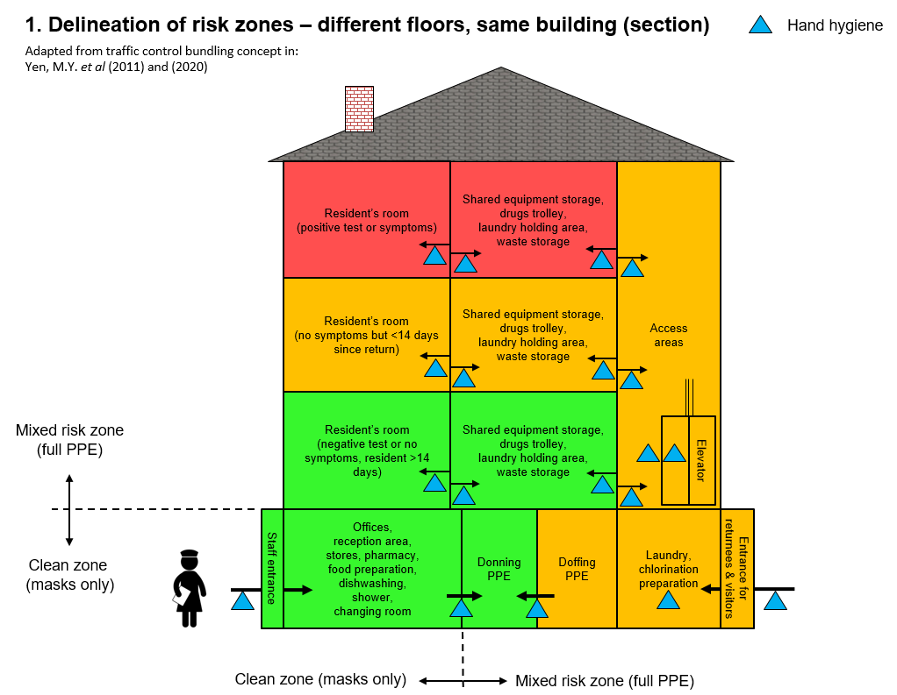
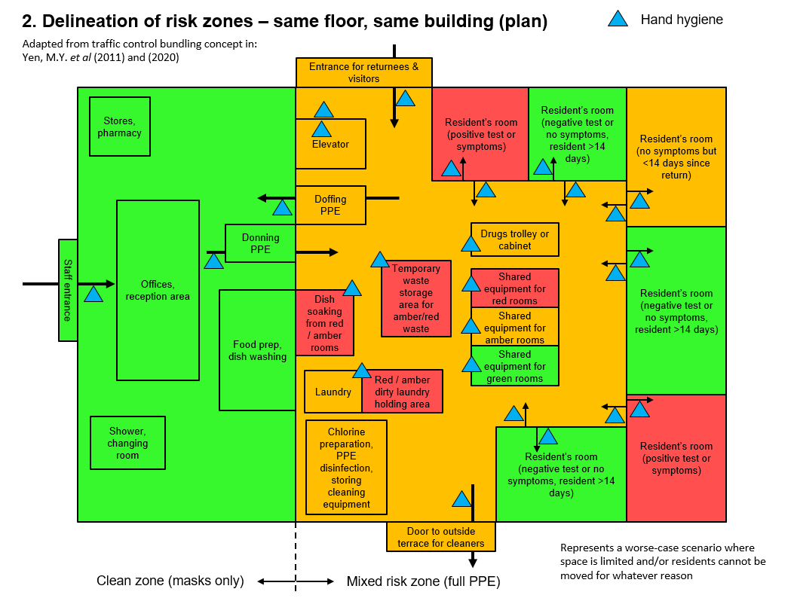
You will need to map your care home and decide which areas are which zone, and where the PPE on/off area(s) will be. Try looking at the care home floor plan with an open mind to identify areas that would offer the ability to be separated from the rest of the home. Experience shows that zoning in care homes can work well where zones can correspond to fire zones – for example, there will be a natural break in the hallways where the fire zones meet, and the use of internal locks linked to the fire system enables large areas to be broken down into manageable areas. Fire zones across one floor are also highly likely to have two different entrances, which works very well in creating completely separate entrances and exits for different staff teams.
To do this, you need to decide which resident should be allocated to which zone (meaning zones can change over time, depending on illness or recovery). Allocating residents to zones is a challenge however, since there is growing evidence of asymptomatic and pre-symptomatic transmission of Covid-19 in care homes, and that symptom-based screening can fail to identify around half of residents with Covid-19. This means for example, that you might assume a resident is not infected because they appear healthy and have no obvious symptoms, which puts them in the green zone – but it could be that in reality they have Covid-19 and are infectious (note: asymptomatic or pre-symptomatic people are very infectious with this version of coronavirus (SARS CoV-2) compared to the previous version from 2003 (SARS CoV-1), since the virus load peaks 5 days earlier with SARS CoV-2, which is anywhere between 1 and 6 days before symptoms appear). For an explanation about asymptomatic transmission in care homes, see section 20 in this document, as well as the explanation in this webinar (starting at 9 mins into it): https://youtu.be/QNN9iTnnRH0.
This means that we cannot rely only on symptom-based screening, and underlines the crucial importance of the zoning approach for the entire building, combined with other stringent infection control measures across all zones.
Deciding which residents are in the red zone:
- Any resident with a positive test result. Note that these residents should remain as red zone for at least 14 days. Note that some research has shown that a proportion of positive cases can shed the virus for longer than the standard 14 days (a case study from a London care home found 3 out of 20 positive cases were still shedding viruses up to 4 weeks later – see 32 minutes into this presentation: https://covid.joinzoe.com/post/webinar-covid-research). These so-called ‘long-shedders’ might be more common in some older people who may not be able to develop immunity responses as easily/quickly as younger people.
- Any resident who is known to have been in contact with a confirmed case of Covid-19 (this could be someone who had contact with an essential visitor, or a staff member that got tested positive)
- Without doing a test, symptoms are nevertheless one method we have to help decide whether a resident is more likely to have Covid-19 (and therefore be categorised as red zone). Daily health checks and close awareness / monitoring of any health changes in residents can look for the following indicators in order to make a decision:
Symptom | When it indicates a possible issue
Body temperature (use ear thermometer & plastic cone) | If fever of > 37.8 degrees (but note: elderly often have no fever)
Cough | Persistent cough
Shortness of breath
O₂ saturation | >5% absolute drop in O₂ saturation
Sore throat
Loss of sense of smell
Loss of sense of taste
Sniffing
Muscular / joint pain
Headaches
Nausea / vomiting
Diarrhoea
General malaise
New onset or worsening confusion | Care home staff with detailed knowledge of residents are well-placed to intuitively recognise these subtle signs
Loss of appetite / weight loss
Skin rash
Conjunctivitis / photophobia / eye pain
Skin rash
Apathy / drowsiness

Deciding which residents are in the amber zone:
- Any returning resident without symptoms needs to be classed as a ‘suspected’ case, and need quarantine for 14 days. After 14 days since returning, their room can become green.
Deciding which residents are in the green zone:
- Any resident with a negative test or no symptoms AND if resident in-situ over 14 days.
You will need a centralised recording system to record residents’ status. This itself can be a challenge, since pens / paper cannot be taken across from the green office zone to the PPE zone. So there needs to be a mechanism of recording daily colour codes for different rooms that can be printed / written in the office zone, but seen in the PPE zone (e.g. lists taped to a dividing window). Whatever recording system is used, for the zoning concept to work it needs to be very clear every day which room is green, amber or red (alerts relevant staff whether or not to go in).
The challenge in a care home is having a mix of amber / red / green areas after donning (putting on) PPE. Combined with the likelihood of having asymptomatic residents or staff, this complexity means that we must be obsessive about preventing cross-contamination between residents between zones, in order to keep uninfected residents safe. This means:
- Dedicating all staff (including cleaning staff) to serve only certain zones, with separated rotations, and ideally keeping the same staff allocated to each zone over time (see section 4 below).
- Constant hand hygiene when crossing zones (e.g. on both sides of each door, or near buttons outside/inside an elevator, see section 3 below).
- Having a rational plan for the use of elevators, which are a risk area for transmission. Some ideas include:
  - If there is more than one elevator, consider having one dedicated to red / amber residents or any potentially contaminated items (e.g. waste / laundry), and the other dedicated to green residents / staff.
  - If there is only one elevator, consider having set times in the day when higher-risk people or items are transported, after which the elevator can be cleaned.
- After exiting a red / amber room avoid touching handrails / walls / items before doffing (taking off PPE) area.
- During a rotation where staff will visit more than one resident’s room, staff must change PPE between rooms, and this should be in dedicated PPE changing areas (see section 9 below). This is because using one set of PPE and then going with it to a second room will introduce risk of contamination (e.g. it is possible that you will need to lift / touch residents or other items, meaning that a contaminated apron / gown from the first room can come into contact with the person / item being lifted).
- In the case that a staff member has to handle / lift a resident when they are outside of their room (e.g. in the garden and fell over), then PPE should be changed after the handling procedure.
- Hand hygiene
Hand disinfection needs to happen at multiple places, many times a day:
- Between handling residents, WHO recommends changing gloves and performing hand hygiene in between (usually with an Alcohol Based Hand Rub).
- Apart from this, based on experience from the SARS outbreak in 2003, we also recommend performing hand disinfection even when gloves are on, in order to reduce transmission of the virus from / to different surfaces in the environment. This is because transmission of the virus happens not only from infected residents to your gloves, but also from various surfaces to your gloves as well. So the routine is to disinfect-touch-disinfect when coming in contact with high-touch surfaces. For example when going into a room, disinfect hands, open door to resident’s room, disinfect hands once door is closed. Or when getting medicine from medicine trolley, disinfect-get meds-disinfect. We are aware that the current UK guidance is to not disinfect gloves because of fears about glove deterioration with repeated use of disinfectants – note that in such a case (where following this guidance and where gloves are not to be disinfected), then they must be discarded and replaced after touching each high-touch surface, even during one episode of care with one resident (e.g. after touching a door handle in the middle of helping someone or going out of the room to get medication, or after touching something like a bed rail during manoeuvring someone). On balance therefore, we have felt that the risk of potential glove deterioration (in which the worst case scenario would be that some virus might reach the carer’s fingers before doffing) was less than the risk of both increased contamination of the carer’s body (which can happen through more “touch” points between contaminated gloves and wrist when changing gloves too often) and increased contamination of high-touch surfaces that would transmit the virus on to other staff or residents. In any case, gloves-on disinfection has been known to reduce infections in health care settings, not only from the SARS outbreak in 2003 but more recently from acute settings in Germany where increased gloves-on hand hygiene decreased infection overall when carrying out multiple tasks on the same patient. Also glove types were tested following the Ebola outbreak and after 6 applications of alcohol-based hand rub most gloves were still found to be stronger than the required safety standard – interestingly here they did find that ethanol-based hand rubs had less impact than isopropanol-based hand rubs. Having said that, more research is still needed on the effect of disinfectants on vinyl gloves that are more common in care homes (compared with nitrile and latex gloves on which tests have been done).
- Hand hygiene is also done when you change out of your PPE – but here also note that where long-sleeved gowns are not used, you should also wash any bare arms with soap and water.
- Note that if hands are visibly dirty / soiled, then it is better to use soap and water rather than alcohol gel.
The type of alcohol-based hand products should contain at least 70% alcohol. Alcohol-based foams are also available (maybe more available right now) and more suited for areas where residents have alcohol dependencies.
Vivid signage at each hand hygiene point will help to remind (see section 14 for ideas).
These hand disinfection points need to be located at all points between risk zones (see zone layout), such as:
- PPE donning (putting on) area
- PPE doffing (taking off) area
- Both sides of every resident’s door
- At the storage point of shared equipment items
- At the drugs trolley
- Outside each elevator door on each floor, and inside the elevator
- At all entrances / exits to the building
- At any temporary waste holding area
- At the laundry

- Staff allocation & rotation in relation to zones
To reduce risk of cross-infection, allocate staff to certain zones (including cleaning staff) and try to have as little interactions between the different groups of staff as possible:
- Staff allocation where staff come and go every day:
  - Staff should be allocated to either work in red, amber or green zones. A practical way of doing this once there is one or more positive cases in the home, would be to trace those staff who had been in close contact with those positive cases, thereby making them part of the team working in the red or amber zones – this might reduce any crossover transmission to other residents in case the staff members themselves were positive.
  - Ideally staff should continue to work in those zones every day when they come to work (rather than swapping over).
  - Try to maintain as much separation as possible between staff groupings at all times (e.g. even when back in the shared green office zone, groups could have separated spaces for activities).
- Staff rotation: where staff have been allocated to certain zones (e.g. one group allocated to the green zone, another group to amber, another group to red), staggering staff shifts by zone might also help contribute towards avoiding cross-contamination between staff (since there would be less proximity during work duties). So for example, one hour could be set aside for green staff shift, then one hour for amber staff shift, and so on). However, we acknowledge that in reality this might be impractical.
- If there are not enough staff to allocate shifts solely for amber or red rooms, then where staff must access both amber and red rooms in the same rotation, they should start with amber rooms first, then red rooms (but with PPE change between each individual room).
- In cases of very limited staff (e.g. one cleaner in small care home), cleaning by rotation using the same principle would be the way forward – e.g. first shift cleaning green rooms, next shift cleaning amber rooms, next shift cleaning red rooms (but with PPE change between each individual room).
- Use of equipment
Cross-contamination risk from equipment needs to be eliminated, both from the green zone (office area) to other areas (the zones after PPE donning), but also between green / amber / red rooms. Some ideas to help include:
- Banning use (and carrying of) personal mobile phones by staff when in full PPE – the temptation / risk is too great to respond to calls and messages while not performing hand hygiene both before and after touching the phone. Leave these phones with personal effects in the green zone office area (you will need somewhere for staff to lock valuables in).
- Where bleeps, phones any hand held devices are required for work within full PPE areas, these then need to be allocated to those areas and left there. For example where care planning systems require the use of a phone app, it would be better to supply designated phones bought for use in these areas. Don’t bring these items back to the green office zone. Where computers are required in the PPE zone, these should also be permanently allocated to that side – for example what has worked in other outbreaks is to use an iPad in the higher risk zones that is connected wirelessly to a computer in the lower risk zone.
- Simple things like pens and paper should also not cross to and from the green office zone. Have a stock of ‘dirty’ pens and paper, then when you need to transfer notes to office staff, tape the paper on the windows of the PPE zone, then copy the items behind the window of the clean zone.
- Any equipment needed for residents should be kept within the PPE zone, and should not come back to the green office zone.
  - Where there are enough supplies, the ideal situation is that some equipment is kept in rooms for individual use (e.g. saturation meters, thermometers).
  - Some equipment will need to be shared between rooms though (e.g. BP machine, hoists, commodes, cleaning equipment like mops and vacuum cleaners) – in this case:
    - Separate out and store for each zone equipment that is shared (green, amber and red) in separate dedicated storage areas (i.e. don’t use red equipment in a green zone).
    - Wash and disinfect each item after each use, regardless of which zone it is for (see section 19 below).
- Another point is that residents should not immediately share books and other items that are usually communal – the safest way will be to leave the items in quarantine for 5 days between uses (this give enough time for any virus to die off).
- Entrances: staff & resident flow
Returning residents or essential visitors (e.g. family members for terminally ill residents, district nurses or GPs) may introduce COVID to the green zone. So if possible, dedicate one entrance for staff (into green zone), and a second entrance for everyone else directly into the amber zone. It also can help to have a dedicated named person responsible for running the ‘meet and greet’ service at every entrance and exit.
If a visitor room is created (see section 7), this will need a separate entrance to the outside, rather than an entrance from somewhere within the building.

- Isolation / quarantine / communal living / visitors
All care home residents should be assumed as vulnerable and in need of shielding from the virus, but we recognise that isolation itself is hard for residents with serious effects on people’s mental and physical wellbeing, and that this situation will continue for many months to come. So while isolation and quarantine are measures to use when there is a confirmed case in the home, you will need to invent safe and risk-free ways for interaction when there are no confirmed cases. We have tried to outline some of these below.

Room layout & sharing arrangements
The first thing to do is consider room layout and sharing arrangements – we would suggest:
- For residents whose COVID status is not known, or where they are negative, each resident should have own room / bathroom.
- Experience from care homes has shown however that the sharing of rooms can also be beneficial from both the point of view of preventing social isolation (where residents wellbeing improved after having social interaction), as well as allowing more intense support from care staff who are not having to move from room to room. In the case of shared / multiple occupancy rooms, and / or shared bathrooms:
  - Residents sharing rooms should be grouped (cohorted) according to: asymptomatic, suspected or confirmed (i.e. symptomatic residents should not share with asymptomatic residents, and suspected cases should not be grouped with confirmed ones).
  - Residents isolating in their own rooms but sharing bathrooms:
    - For toilet purposes, ideally a dedicated commode (and bed pan / urine container as appropriate) would be most appropriate in order to reduce the need for those in isolation to keep coming out of their rooms.
    - Keep in mind that just because residents are in the red and amber zones, this should not mean they receive less care as a result, especially for issues around hygiene and dignity (e.g. bathing – there have been cases where people in isolation had not showered for weeks in the case where there were communal facilities because of concerns over rules for isolation). Residents in isolation are already in a stressful position, and not having access to basic hygiene will only add to that. For showering, there should always be a way to work around a situation (e.g. allocating certain shared bathrooms as red or amber and disinfecting between uses).

Isolation & quarantine for when there are confirmed cases in the home
Where you have a confirmed case in the home (resident), it would be less risky to:
- Isolate everyone in their rooms and have no social interaction, until 2 weeks have passed since the last case and/or everyone is tested negative.
- All meals should be taken in rooms, with no communal dining and no visitors being allowed.
While in terms of infection control this might be sensible, we realise however that this will be very difficult to achieve, especially for those with dementia, and other strategies will be needed (e.g. increasing levels of one-to-one care and involving them in more activity to reduce the tendency to ‘walk with purpose’).

Internal social interaction & visitors for when there are no confirmed cases in the home
Where you do not have confirmed or suspected cases, you will of course still have the risk of transmission from asymptomatic or pre-symptomatic staff, visitors or residents. But social interaction is possible – the thing is to just create ways where the virus cannot pass from one person to another through physical touch or airborne transmission.
For internal interaction (resident to resident, or resident to staff), we suggest:
- Still maintain internal social distancing – this means no ad hoc internal resident to resident visiting or socialising where 2 metres distance cannot be met. Any areas where this cannot be guaranteed should be taped off. To help with this, some ideas include:
  - To calculate maximum occupancy rates for each room (and post it on the door for example) – a rule of thumb can be to allow minimum 6 m² per person based on the floor area.
  - To have tables with Plexiglas (clear solid acrylic) divisions so that residents can still chat in a semi-communal setting.
- In addition it will be good to give the option for residents to use face masks if they wish to do so when accessing communal areas. We now know that transmission is greatly reduced by mask-wearing (see section 9), and also some residents may feel safer using one, yet we also realise that for many residents this will not be possible for various reasons. However the option should be there (and actively encouraged where possible).
For external interaction (visitors), with the advent of certain rapid tests there are now more options open to us. However, it is very important to understand that rapid tests should not be considered as fool proof or ‘the answer’ to know if someone is infected or not (see section 1). As there will always be risks associated with these tests, they should therefore rather be viewed as another string in our bow for reducing risk, and it will still need to be up to the care home to decide the risk they are willing to take. With that in mind, instead of simply allocating close contact visits to take place for all relatives who submit to a test, we would rather promote a triage system where visiting protocols vary according to the needs of specific residents:
- For those residents that are managing fine with current visiting protocols (e.g. socially distanced as set out below) we would suggest continuing in that way as it is lower risk.
- For other residents where the risk of not having close physical contact may pose a higher risk in terms of deterioration than getting ill with the virus, we suggest that the definition of ‘essential visitor’ (see below) might be expanded to include these residents, where a rapid test can be a ‘good enough’ indication to allow physical interaction. However, it is not without risk to them or others – where visits with close physical contact are deemed necessary, keep in mind that there is always the risk of possible transmission to not only that resident being visited (who may not mind risking to get the virus) but to all the other residents in the care home. This is the main reason why we would suggest not having the same policy for all residents.
Suggestions for visiting protocols that limit physical interaction are:
- Increase online face time with relatives (but note if sharing a device, this has to be fully disinfected between uses if shared).
- Facilitate visits but in a different way that does not carry the risk of residents receiving the virus from outside. Staff will have to be closely supervising these interactions to ensure that visitors strictly adhere to guidance. Some examples of ideas:
  - Allow relatives to visit but remain outside a window.
  - In good weather, consider having a dedicated outdoor space where interaction can happen at a safe social distance. Visitors must wear masks (and ideally residents as well) since it is known that the virus can travel further than 2 metres and remain in the air, and how far it can go will depend on things like local wind conditions – so having a mask will reduce this risk dramatically.
  - In colder weather, or where the garden cannot be used, consider creating a dedicated visiting room with a Plexiglass (clear solid acrylic) wall that completely blocks physical access from one side to the other, yet has a system that allows people to talk but where residents are still shielded. Some care homes have trialled ‘visitor pods’ along these lines. But in this case, going back to our principles of infection control:
    - This room should have a separate entrance for visitors directly from outside – this means the entrance should not be via the staff green zone, otherwise visitors risk contaminating that area, from where contamination can then be taken to residents by staff.
    - The part of this room where the visitors are located should be sufficiently ventilated with either a single room ventilation unit or HEPA air filtration unit – even where there is low likelihood of air moving from the visitor side to the resident, it is good practice in order to protect subsequent visitors. For risks of airborne transmission and how to calculate what unit is required, see section 17.
    - In addition, visitors themselves should also be protected – this means visitors should wear masks and perform hand hygiene on entering and leaving, and any high-touch surfaces should be disinfected between visits (e.g. door handles, tables, chairs).
- Exceptions to this might be an ‘essential visitor’ who must have physical interaction – this might be:
  - Someone who is allowed to visit a terminally ill resident. In such a case, rules should be relaxed. Just ensure that contamination from visitors cannot enter the rest of the home – for this therefore, try to move the resident to a room with an external door so that visitors can come and go directly.
  - A GP / nurse doing rounds.
  - In either case, a health check for visitors is needed on arrival (as per section 15) and full PPE should be worn by visitors, and the donning / doffing procedure supervised by staff before and after the visit.
Government guidance also suggests limiting visitors to a maximum of 2 constant visitors per resident – this means having the same people visit each time.

For residents with dementia and those experiencing emotional distress
To care for residents with dementia is admittedly one of the most challenging circumstances, and there are no easy answers on this. It is important to get right, since about large proportion of people in care in the UK have some form of dementia.
People with dementia may ‘walk with purpose’, which means that they may like to walk around purposefully and may become distressed if constrained, so this makes isolation particularly challenging. There are also added complications in that staff may have a tendency to remove all aspects of decision-making from the people living with dementia, rather than still trying to support them in making the decisions they are able to make, such as when to eat or when they would like to drink. So it is important for the care home to try to ensure as much as possible that people with dementia still have some ability to make decisions for themselves, whilst also being encouraged to follow infection prevention protocols.
In general, what we do know is how the virus spreads, and close contact is one of those ways. So even if zoning / infection control is in full force, close contact to staff still carries risks since the virus can pass from someone with dementia to the staff member or vice versa, and then from this person with dementia to another resident. This risk will always be the case where there are staff and / or visitors from outside that will enter a facility on a daily basis (these will bring the virus in). Therefore the following could be ways forward:
- One solution for those with dementia who require close contact, would be to already have dedicated buildings / floors / wings dedicated to them (whether they have COVID-19 or not), where they have some ability to move outside their room, such as to a communal area, but not to go within the wider home area. In this situation, the staff would be cohorted but would still come and go at the beginning and end of their shift.
- Where there is an outbreak of COVID-19, infected individuals would then be cohorted in a dedicated red zone, again a place which ideally would have its own communal area.
We have put together a review of good practices in working with people with disabilities which is available here: http://bushproof.com/?smd_process_download=1&download_id=3301. In addition, we have found that the following resources might provide some ideas for managing those with dementia:
- Top Tips around 8 topics that had been raised by care homes related to dementia, where guidance was grounded in good practice and experience: https://ltccovid.org/2020/07/01/new-resource-top-tips-for-tricky-times-evidence-and-guidance-grounded-in-good-practice-and-experience-to-support-care-homes/
- Detrimental effects of confinement and isolation on the cognitive and psychological health of people living with dementia during COVID-19: emerging evidence. https://ltccovid.org/2020/07/01/detrimental-effects-of-confinement-and-isolation-on-the-cognitive-and-psychological-health-of-people-living-with-dementia-during-covid-19-emerging-evidence/
- Staff clothes from home / showering
- Have a changing room on site. On entering, change from home clothes to work clothes / shoes (be that a uniform, scrubs or other). On leaving, change out of work clothes / shoes before travelling back in home clothes. Note that some care homes have required this only for those entering the amber or red zones.
- We recommend to launder work clothes at the care home (there may be more risk the further dirty clothes have to travel), doing so regularly using thermal or low temperature chemical disinfection cycles, followed by ironing or tumble drying. Where this is not possible, clothes taken home need to be put in a cloth bag (that can be laundered with the work clothes without removing them from the bag) and then to put this into a plastic bag before being transported. The plastic bag used for transporting the clothes needs to be disposed of safely. Please see section 13 (Laundry) for full details on laundry guidelines for staff clothing.
- Experience shows that having a staff shower facility in the care home before leaving greatly helps staff to feel safe before going home.
- Personal Protective Equipment (PPE)
PPE needs to be worn to all residents’ rooms (red, amber or green) and access areas to these rooms, as well as to any red / amber zones in the layout.
However in some cases it might not exactly be so clear cut when it comes to wearing PPE and preventing contamination – for example:
- Residents who are hard of hearing and outside of their room (e.g. some are allowed outside but not in groups): here it will be particularly good practice to wear a face shield and mask (which we are suggesting should be done for all resident contact), when communicating with them, since they may need to get closer than what is ideal to understand what is being said.
- Residents with dementia: person to person contact may be unavoidable in certain cases, so in these cases adhering to strict hand hygiene and changing into clean sets of clothes prior to contact, along with use of full PPE, might be the only way forward. Allocating live-in staff to that zone where there is no other contact with the outside world, might also be the only reliable option here.

Recommended PPE
The type of PPE that Public Health England now recommends for staff in care homes is found here (version 8, dated 2nd November 2020): https://assets.publishing.service.gov.uk/government/uploads/system/uploads/attachment_data/file/931616/How_to_work_safely_in_care_homes_v8_2_11_2020.pdf. This recommends PPE type according to type of task and follows the list below (left column), while allowing that some care homes will require PPE for Aerosol-Generating Procedures (AGPs) that might occur in more complex care (for which we have added the right hand column):
Full PPE for green, amber & red rooms after donning PPE
Full PPE (day-to-day activities) | Full PPE (for Aerosol-Generating Procedures (AGPs))
- Fluid-repellent surgical mask (FRSM / type IIR)  - Apron (disposable)  - Gloves (disposable)  - Eye protection / face shields | - Filtering face piece respirator (FFP2 / FFP3 / N95 without exhalation valve)  - Long-sleeved fluid-repellent gown / coverall  - Gloves (disposable)  - Eye protection / face shields

For aerosol-generating procedures, an FFP3 mask can also be used, which is even higher specification than an N95 or FFP2 mask. However, when choosing any of these, make sure that these are the ones without exhalation valves – this is because if you are infected and wear a mask with an exhalation valve, the outgoing air is not filtered and there is a risk that you infect others. Some N95 and FFP2 masks (and most of the FFP3 masks) have exhalation valves, so you need to check. Also there is concern that N95, FFP2 and FFP3 respirators with ear loops may not have a tight enough seal to protect when doing aerosol-generating procedures, so check official guidance before purchasing. Note that respirators need to be fit-tested (made sure that they fit your face shape to establish a seal effectively – see below for details).
Also, due to many fake brands of respirators now available (with false official markings / certificates of safety which often appear authentic), if you need to purchase a quantity of masks we recommend to refer to guidance on this issue. The following websites are useful:
- https://www.bohs.org/wp-content/uploads/2020/07/Spotting-a-Fake-Understanding-FFP-Markings-Branded-14_07_2020.pdf
- https://www.cdc.gov/niosh/npptl/usernotices/counterfeitResp.html
Note that face shields might be more user-friendly for older people, especially those with dementia, since face and eyes can be more clearly seen, although they do not prevent a staff member passing on the virus through their normal breathing to the same degree that face masks do. Another idea that helps residents recognise staff is to laminate a face portrait of each staff member which they can pin to their uniform – these should be wiped down and left at a designated point in the amber zone (rather than being brought into the green zone).
The guidance above is a basic minimum level. If it is possible, we would also recommend the following additional items where possible for care homes:
- Heavy-duty aprons (rather than disposable ones). This means that these could be disinfected and re-used, reducing ongoing PPE needs.
- A long-sleeved washable coverall or gown (for all work, not just aerosol-generating procedures). The rationale being that more of your uniform/scrubs can be protected compared with just using an apron, and in an ideal situation there would also be enough spares so that the coverall/gown could also be changed when PPE is changed, instead of continuing the whole day in clothes/uniform that might have been contaminated (outside of the area that had been protected by the apron).
- Heavy-duty rubber gloves (for cleaners). Again having a stock of these means they can be disinfected and re-used.
We realise that PPE stocks have been limited in many places. Some things you can consider to help this situation include:
- Disinfecting and re-using certain types of PPE, which can increase availability (see below).
- Ideally we would change full PPE between each resident, since we don’t know for sure if residents in one zone are all non-infectious even if they don’t have symptoms. However, circumstances may well dictate that we have to ration PPE, in which case changing only part of the PPE between each resident might have to be the way forward. The question then is which part of the PPE should be changed after each resident, and which could be used for a ‘session’ or shift (i.e. 2 – 6 hours). Logically, cross-contamination where PPE is not changed between every resident will mainly come from surfaces that get touched – this means the gloves, aprons and what you wear under the apron such as uniform/scrubs. In contrast, the mask and eye protection are less risky as long as you (or others) don’t touch/move these. The challenge is to take off and put on certain items of PPE while keeping mask and eye protection in place, since you don’t want to cross-contaminate items, and since you must deviate from standard donning protocols. So therefore where PPE stocks are low, you will probably end up concentrating your efforts on only:
  - Changing gloves between each resident.
  - Changing aprons at the same time, but note that this may be more difficult due to the doffing and donning routine (i.e. in the case apron ties cannot be broken which would require having to put apron over head while mask/eye protection still on).

Some notes on masks in general
For cleaners who carry out vacuum cleaning, we recommend they use the higher grade FFP2 / FFP3 / N95 respirator for aerosol-generating procedures (due to as yet unknown effect of circulation of viruses in exhaust air from a vacuum cleaner, but we do know that the virus can survive for hours in circulating air currents).
We recommend masks to be worn by all staff the whole day, even when not in full PPE (i.e. when in green office zone), and also when travelling to and from work (i.e. using public transport) – this is to prevent staff both getting infected (e.g. on public transport) and then giving infection to residents (when on shift). The reason for this recommendation is that it is now clear from recent research that airborne transmission is a risk from both droplets and aerosols, and that wearing a mask both reduces the risk significantly of someone who is infected from transmitting the virus, but also helps protect someone who is uninfected. The WHO therefore is now recommending widespread use of masks in public. The risk of transmission when masks are not used also exists from asymptomatic carriers – this risk increases when light activity is carried out (i.e. walking around, similar to what care staff would be doing), in closed spaces with more people present (i.e. communal areas, offices, meeting rooms), and where there is insufficient ventilation (i.e. where windows are closed, or where there is no mechanical ventilation system). For a review of the recent evidence around airborne transmission and the effectiveness of masks, there is a link on the care home document holding page: https://www.bushproof.com/care-homes-strategy-for-infection-prevention-control-of-covid-19-based-on-clear-delineation-of-risk-zones/.
A few things to keep in mind in general when wearing masks:
- If you need to talk, do this through the mask.
- If you need to take the mask off (e.g. to eat), remember that a mask should never be lowered to chin or put on the forehead, and it should not be taken off and deposited anywhere except either a bin (i.e. should not re-used) or a storage container (in the case of FFP2 / FFP3 / N95 masked that are re-used – see section on ‘Re-use of PPE’ below).
We also recommend masks to be worn by all residents where possible, as long as they can tolerate them:
- For symptomatic residents who are isolating, make sure they have access to masks, and ask them to use them when they leave their room if they are to use a communal toilet or shower room (and definitely do this when moving a resident from room to room).
- For asymptomatic residents who have access to communal areas, it would also still be best to give residents the option to wear a mask if they so wish. This is because masks are now known to both prevent spread of the virus from infected individuals, as well as protecting uninfected individuals from receiving the virus – therefore in the case that a resident or staff member is asymptomatic but does not know it, wearing masks will reduce the transmission risk overall for everyone. However, we realise that this will not be practical for many residents (e.g. those with forms of dementia), but it would still be good if the option is there for those that want it.

Fit and seal tests for FFP2 / FFP3 / N95 respirators
For respirators (FFP2 / FFP3 / N95) specifically:
- Remember that masks should cover both nose and mouth. For men who have facial hair, they should check the following diagram to see if it will work safely with a mask: https://www.cdc.gov/niosh/npptl/pdfs/FacialHairWmask11282017-508.pdf.
- A fit test is needed to first see which mask fits you, and then a seal test is needed every time you put on the mask. If the mask does not fit perfectly, you will not be protected from COVID-19 (and other respiratory diseases).
  - Fit test:
    - Everyone has a different shape of face, and one type of mask might fit better than another. So it is good practice to have at least two different makes of respirator mask available for people to use.
    - If a fit test cannot be done in the care home, then staff must be sent to a health centre, or a care home where staff have been properly trained to do this.
    - Note that a fit test should be redone if someone changes weight, or has dental work done (in the longer term).
  - Seal test:
    - Always check the instructions from the manufacturer about how to conduct the seal test, as it can vary according to the brand.
    - If doing a seal test for a respirator that you are re-using, ideally you should use gloves for doing this, then dispose of them and perform hand hygiene. If this is not possible then do very rigorous hand hygiene after putting it on.
    - Once fitted, check for leaks by covering the respirator with both hands and forcefully inhale and exhale. The respirator should collapse when inhaling and expand when exhaling, and no air leak between the face and the respirator should be detected. Refer to this WHO guidance regarding this: https://www.who.int/csr/resources/publications/respiratorsealcheck/en/

Re-use of PPE
If there are shortages, it should be possible to re-use some PPE – see the following table.
Thermal Disinfection 71°C for 11 mins or 65°C for 18 mins, includes obligatory mixing time of 8 mins for full temperature penetration of load.  Low temperature disinfection Alternatively, disinfection may be achieved at lower temperatures, for example using ozone where this is continually fed throughout an automatic laundry wash cycle or using chlorine (white linen washed below 50°C only). | Disinfect using 0.1% chlorine for at least 10 minutes | Dispose of, do not re-use | Re-use as last resort: allocate 5 items to each staff member, wear one each shift, store each one 5 days in labelled breathable paper bag at end of each shift, use them in order.
Some purpose-made medical gowns | Eye protection / face shields | Disposable latex gloves | Masks for AGPs (filtering face piece respirator, FFP2 / FFP3 / N95).
Scrubs | Heavy-duty rubber gloves (for cleaners) | Masks for day-to-day activities (fluid-repellent surgical mask, FRSM / Type IIR)
Coveralls / lab coats | Heavy-duty aprons. For aprons composed of non-natural rubber materials, low temperature chemical disinfection may be used e.g. ozone.⁴ | Disposable aprons

Regarding the information in the table above (last column) about re-use of masks as last resort – note that:
- This is not ideal by any means, but is at least a logical way to approach it, given what we know about the lifespan of this virus (storing it long enough, the virus dies off).
- But this is only considered a valid approach for the higher-grade respirators (FFP2 / FFP3 / N95).
- Although FFP2 / FFP3 / N95 respirators can be used for sessions (i.e. 2 – 6 hour shifts), depending on the number of shifts you might need to allocate more masks per staff member for this to work. The actual number to allocate to each staff member needs to be enough to allow 5 days between the use of each mask.
- A good labelling system needs to be in place to keep track of this. Note that you should never write on the mask material, but rather stick a label on the strap.
- Discard a mask if it is wet, stained, contaminated by body fluids (e.g. nasal secretions), damaged, or straps are loose. If the inside of the mask becomes contaminated by touching, discard it.
There are some alternative PPE options such as:
- Long-sleeved lab coats or work overalls instead of purpose-made gowns
- Construction type eye protection glasses (the type with extensions at side of eyes)
- Swimming goggles. Note: if using sealed goggles, these tend to fog up – however, experience from Ebola treatment centres showed that wiping the inside the lens first with wet wipes and allowing to dry before putting them on tended to help prevent fogging.

Donning & doffing
There needs to be at least 2 dedicated areas for PPE donning (putting on) / doffing (taking off), although there might be more than this. Key thing is that these should be separate / segregated areas (even if physically close to each other), and are specific places where PPE is put on or taken off (i.e. do not take PPE with you into the rooms). The space in these areas needs to be big enough to allow people to keep 2m distance (maximum people at any one time depends on space, maybe put a sign up on door stating this).
Donning & doffing needs to follow clear / strict protocols.
It is completely essential that staff have good hands-on training about how to put on and take off PPE without contaminating themselves (English may not be their first language, practical demonstrations will help).
- A good video on donning and doffing that has the appropriate hand hygiene steps can be found here: https://www.cdc.gov/coronavirus/2019-ncov/hcp/using-ppe.html.
- Hand hygiene is well-known as one of the most effective methods to stop transmission of diseases. For some visual examples that care home managers might even try with their staff as training, see this video clip (starting 20 mins in): https://www.youtube.com/watch?v=WeV_b8YM9kE&feature=youtu.be

Donning (putting on) areas should have:
- Bench/chairs
- Shelves for orderly arrangement of PPE
- Donning poster (note: depending on which PHE guide you are using, add a hand hygiene step at the start)
- Mirror
Doffing (taking off) areas should have:
- Waste disposal (labelled as washable / re-useable items, or non-washable / disposable)
- Sink with water & liquid soap (for washing bare arms between PPE changes)
- Doffing poster (note: if using PHE guide, add a hand hygiene step between steps 2 and 3, so after removing gown but BEFORE removing mask or eye protection – see our modified sign which is part of our signage zip file available here: https://www.bushproof.com/?smd_process_download=1&download_id=1587. Rule of thumb: perform hand hygiene after each step of doffing).
- Mirror
- Experience from Milan shows that if there are staff available, having someone to help supervise doffing can add reliability to the process (and reduce possible infection).
- Food preparation / dishwashing
An additional precaution can be to take dirty dishes from red / amber rooms and process them separately (see section 11 below). For this, there needs to be a way to transfer dishes between the dirty areas and the kitchen, with the washing / soaking part taking place in the contaminated zone and not the kitchen itself. Where dishwashers are used in the kitchen, then you will need a separate area for washing with soap and water within the red or amber zones, before moving them to the area to put in the dishwasher.
- Chlorination / disinfection of items & cleaning of surfaces
Chlorine is needed for PPE disinfection, soaking of dishes, and cleaning of surfaces. Note: a dilution of 0.1% chlorine is often referred to – which is the same as 1,000 ppm or 1,000 mg/L – and to make this dilution correctly, see section 19 below.
Procedure in general is to:
- Wash with water / soap first
- Rinse off soap (important since chlorine will react with soap and therefore be less effective)
- Disinfect with chlorine second

PPE disinfection
PPE disinfection of certain items (e.g. heavy-duty gloves, eye protection, heavy-duty aprons) is done by washing with soap and water, rinsing, then soaking for at least 10 mins in 0.1% chlorine, then rinsing and drying.

Dishes
Where dishes are washed by hand, they should be washed with soap and water, rinsed, then soaked for at least 10 mins in 0.1% chlorine, then rinsed/dried.

Surfaces
Cleaning of surfaces needs to happen at least 2x per day in amber / red areas (and dependent on staff can happen more often than that especially during a confirmed outbreak). A rota/checklist will help keep track of what has been done. But you need to prioritise what to clean given your available time / staff resources:
- First priority needs to be given to any high-touch surface – these include bed rails, tables, door handles, any equipment with high touch surface.
- Where time allows, other surfaces that are touched (by hands) less often can follow – these might include hard floors and chairs.
Two options for what cleaning solution to use:
- Start with soap and water, then rinse with water, then disinfect with 0.1% chlorine. Chlorine is what both WHO and UK government guidance suggests.
- Use a non-chlorine disinfectant formulation. There is a wide variety of such disinfectants (e.g. certain alcohols or quaternary ammonium compounds (QACs)), but our recommendation is only to use a particular formulation and concentration that conforms to EN 14476 for the particular application in question (e.g. cleaning surfaces). We have provided some additional analysis of the options and standard requirements for the care home context, which is available here: https://www.bushproof.com/?smd_process_download=1&download_id=1660. There are certain things to note about this:
  - The standard required by UK government guidance is lower (i.e. products used must meet the standard against only enveloped viruses). This is fine for inactivating the SARS-CoV-2 virus, but we recommend the higher EN 14476 standard for products for cleaning in care homes, because care homes also have to deal with other viruses that might not be inactivated by those products (e.g. norovirus, which being a non-enveloped virus is more resistant). So it makes sense to have cleaning products that deal with all of them at the same time.
  - Note that it is a bit confusing that handrub and handwash products, as well as those for surface disinfection, can still be stated to meet the EN 14476 standard if they have only been proven for enveloped viruses, but not the more resistant viruses (e.g. Noroviruses). Therefore it is important to make sure that any product used is stated to both meet the EN 14476 standard AND they have “full-virucidal activity”.
  - The effectiveness of some products is questionable, so it is safer for cleaning products to stick with the confirmation that the EN 14476 has been met.
When using chlorine, the smell can be quite strong, so opening windows to ventilate during the cleaning process will help.
Mop heads or cloths can be disposed of after use (if there is enough stock), laundered either using thermal or low temperature chemical disinfection, or re-used in the same manner as re-use of PPE (i.e. washed with soap, rinsed, chlorinated).

Notes on chlorine preparation
For disinfection using chlorine, you need to have a way to create the necessary dilution of 0.1% strength, depending on type of chlorine used (see procedure in section 19 below) – this should be valid for either chlorine-only or detergent-chlorine products.
Important notes for chlorine use:
- Chlorine products emit a dense gas – best to have the mixing / storage area away from living areas and in well-ventilated space, but not in a basement where this gas will accumulate, and preferably within the amber zone and with link to outside (e.g. terrace for drying).
- Do not store next to fuel, heat sources, dry powder fire extinguishers, other chlorine types, nitrogen-containing compounds, oxidizers, or anything corrosive or flammable.
- Waste
Waste should be treated as clinical waste. You need to have a waste disposal system for red / amber waste versus green waste within the care home:
- Ensure you have clinical waste bags ready in each red or amber room.
- Ensure you have tissues and paper towels available in each room, as well as in communal areas.
- If you place waste temporarily inside the building before it is taken outside, then waste coming from red / amber rooms should be placed in a separate designated red storage zone.
- Pay particular care with the management of incontinence pads, or anything soiled with urine or faeces from all rooms. Studies indicate that the virus can be detected in stools for 5 weeks after the respiratory symptoms stop, so care needs to be taken when handling any contaminated items (here it is a precautionary principle, because we don’t yet know if the viruses are viable and can infect someone else).
- Empty contents from vacuum cleaners while wearing full respirators due to the risk of aerosolisation – any contents from equipment used for red or ambers zones should be put in the relevant designated waste areas.
- Red / amber zone waste should be disposed of as infectious clinical waste. It should be double bagged. In the case that there is no clinical waste stream, a solution can be to double-bag the waste and store it for 72 hours before putting it in the normal waste stream.

- Laundry
All linen used in the care of residents with possible and confirmed COVID-19 cases should be managed as infectious linen. Linen must be handled, transported and processed in a manner which prevents exposure to the skin and mucous membrane of staff, contamination of their clothing and the environment. Linen should be handled in accordance with the Department of Health (DH) Health Technical Memorandum HTM 01-04 guidelines for infectious linen.³

Personal Protective Equipment
- Appropriate personal protective equipment (PPE) should be worn at all times when handling linen – i.e. disposable gloves and aprons, and PPE should be changed between the handling of clean and dirty loads.

Handling Infectious Linen
- All linen should be handled inside the resident’s room or cohort area.
- Do not shake, rinse or sort linen from beds and trolleys.
- Do not place linen on floors or any surfaces.
- Process linen as soon as possible and ensure clear segregation of dirty and clean linen at all times.

Processing Infectious Linen
- Any solids or pads should be carefully removed from linen.
- All infectious linen should be placed in a cold water-soluble red bag.
- Cold water-soluble bags may have a water dissolvable PVA strip or be manufactured completely with water soluble PVA. The former presents the lowest risk to the handler, as the fully soluble / dissolvable option is susceptible to dissolving prior to placing in the washer if the contents have a high moisture content, such as incontinence bed pads or mops.
- Do not overfill the bags and secure using the strip or tying a knot. On no account should these bags be opened. They are designed to contain the load and protect staff handling and transporting to the laundry. They are placed inside the washing machine unopened and will facilitate the release of the load during the first section of the wash process, normally a cold sluice - thereby protecting staff and lowering the risk of any contamination of the environment.

Transporting Infectious Linen
- Soiled linen contained in cold water-soluble bags should immediately be placed in an impermeable secondary red or appropriately coloured linen bag for transporting the linen to the laundry.

Laundering of Infectious Linen
Laundry should be carried out in accordance with DH Health Technical Memorandum HTM 01-04.³ There is no current recommendation for increased microbial parameters.
- Water-soluble bags containing infectious linen are placed directly in the washing machine unopened.
- Infected linen should be processed by thermal disinfection at 71°C for 11 minutes or 65°C for 18 minutes; this includes the obligatory mixing time of 8 minutes to allow full penetration of the temperature through the load. Commercial washing machines should have pre-programmed thermal sluice cycles provided.
- Low temperature chemical disinfection can be employed provided that the process is proven to provide equal or greater disinfection efficacy in comparison to thermal disinfection. Low temperature disinfection may also be more appropriate for heat sensitive materials such as personal clothing, hoists and slings, mattress covers, microfibre cleaning materials.³ Examples of low temperature laundering disinfectants include ozone, which can be continually injected and dissolved into the wash water throughout an automatic laundry wash cycle^{4,} or chlorine. Chlorine is only suitable for white linen as it can bleach coloured textile. It can cause damage to fire-retardant coatings or other specialised textile treatments so should not be used for linen of this nature. Chlorine can also damage linen if used above 50°C.⁵

Staff Uniforms
Healthcare workers should wear a clean uniform for every shift, and should be changed immediately if the uniform becomes visibly soiled or contaminated during the shift. It is preferable to wash uniforms on site (using disinfection parameters outlined for infectious linen above). If on-site laundering is not available, it is best practice for healthcare workers to change out of their uniform at work and transport it home in its own plastic bag.
Where uniforms are laundered at home, they should be washed at the hottest temperature that the fabric can tolerate with detergent before tumble drying or ironing. Uniforms should be washed separately from household linen.^{8,9}
Staff that do not wear uniforms should promptly change out of their work clothing at home after work, avoiding activities such as shopping on the way to and from work.^{,11} Clothing should be washed separately from household linen, using the same guidelines as for uniforms.^{9,10}
- Signage
Signs to help delineate zones & clarify levels of contamination. A zip file containing signs that you can adjust/print is available here: https://www.bushproof.com/?smd_process_download=1&download_id=1587. Signs to consider printing include:
0.1% chlorine (for any containers containing it) | Donning area – Full PPE mandatory | Perform hand hygiene before AND after this door
Red / amber / green shared equipment storage point | Donning area – max … people at a time, do not enter if you can count more than this! | Don’t touch face with hands/gloves
Green waste | Doffing area | Returning resident / visitor entry
Red / amber waste | Instructions for PPE donning (putting on) | Returning residents / visitors please use other entrance
Temporary red / amber waste holding zone | Instructions for PPE doffing (taking off) | Staff entry

- Staff health
For staff deciding on when to come back to work, the most recent guidance from Public Health England is displayed on the flowcharts below (summarised as if unwell, don’t come in to work but self-isolate for 10 days: https://www.gov.uk/government/publications/covid-19-management-of-exposed-healthcare-workers-and-patients-in-hospital-settings).
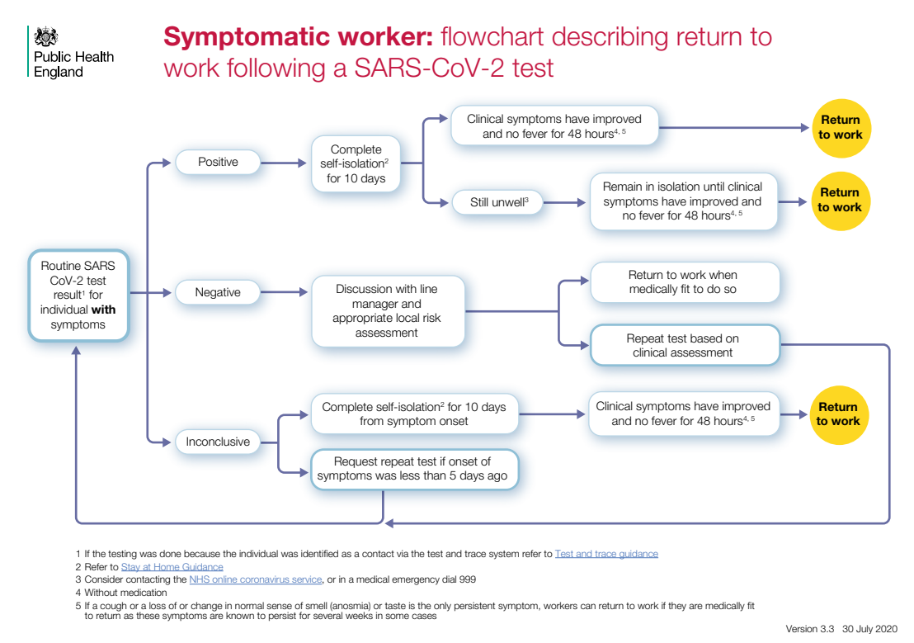
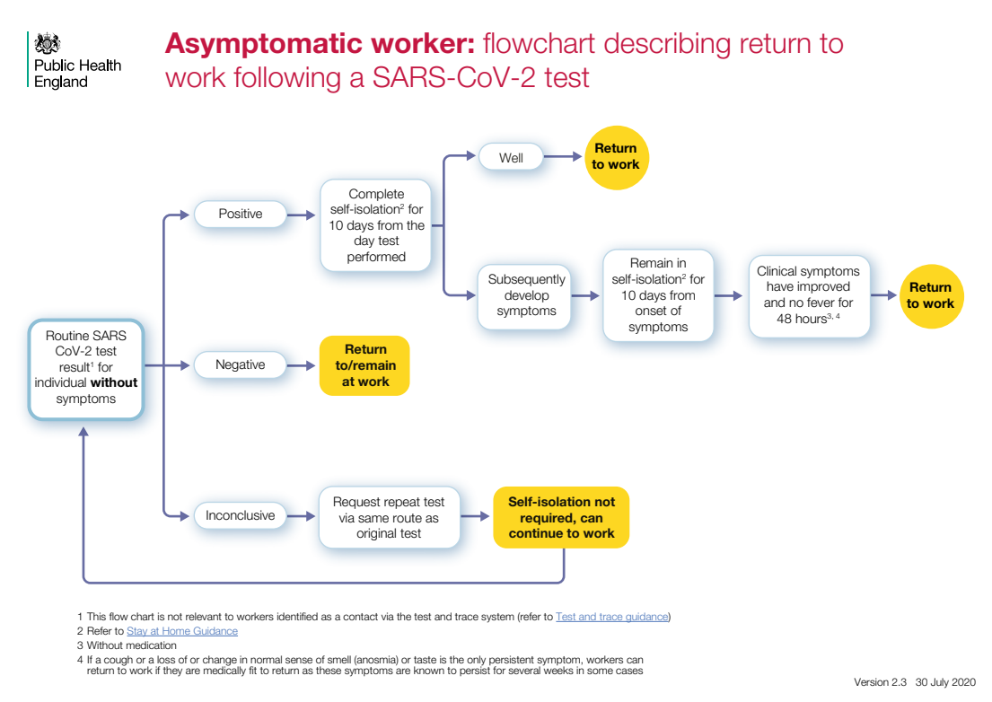
In addition, for those staff that are coming to work every day:
- Carry out a daily symptom checklist for staff before entering the care home (temperature, cough, loss of sense of smell or taste any gastro-intestinal symptoms).
- Remember that in the same way that residents can be asymptomatic and yet have Covid-19, staff can also be asymptomatic carriers and can infect other staff members. Keeping social distancing, wearing a mask and having the same procedure to hand hygiene (disinfect-touch-disinfect) is necessary, even in the ‘safer’ green zone.
- In addition, if regular testing of staff can be done (i.e. all staff including those with no symptoms) then this will help reduce the risk of transmission. The more often this can be done the better (minimum weekly according to government guidance).
- Have a staff break plan which is COVID-secure. Experience from care homes has shown through reverse tracing that the staff entrance / smoking areas were one of the biggest sources of transmission between staff. Therefore such a plan can include having physical points painted on the ground to encourage social distancing, signage outlining rules, adequate ventilation (for non-smoking indoor spaces), and limiting the number of staff in those indoor areas at any one time.
- Encourage staff to carry out their own zoning back at home.
- Encourage use of masks when travelling to and from work (i.e. using public transport) – see section 9.

- Residents’ rooms & aerosols
In general, we want to reduce anything that will generate aerosols as far as possible. Research now indicates that aerosols can travel much further than 2 metres and can also remain suspended in the air for some time. This means we need to try to minimize the amount of forced air movement which could exacerbate this:
- No fans allowed. In heatwaves however, this will be challenging. Where there are clear health and comfort consequences on the elderly if fans are not used, we suggest using air conditioners on low fan speeds and with oscillation turned off. If fans must be used, try aiming air flow towards an open window, and ensure that air does not blow across individuals directly to other individuals.
- Reduced vacuuming schedule for red or amber rooms (since it creates air flow through the filter and recirculation of particles, the effect of which is not known). Use dedicated hoovers for red or amber zones, and ensure staff using them use FFP2 / FFP3 / N95 masks. An alternative to vacuum cleaners could be to use carpet sweepers instead.
- The use of pressurised humidified oxygen, Entonox or medication via nebulisation are not considered to represent a significant infectious risk (see p.31 of the ‘COVID-19 - infection prevention and control (IPC) guidance’ document: https://assets.publishing.service.gov.uk/government/uploads/system/uploads/attachment_data/file/881489/COVID-19_Infection_prevention_and_control_guidance_complete.pdf). However, there are also other methods that are equally effective for giving medication to asthmatics or those with lung disease, but which do not use a nebuliser (e.g. a holding chamber).
- You also need to help residents know what to do if sneezing or coughing (in their rooms, as well as communal areas). This will be educate people to:
  - Cough or sneeze into their elbow, or to put their hand over their mouth when doing so, followed by hand hygiene.
  - To use tissues only once and then bin them.
- Ventilation
More is now understood about the possible risk of airborne transmission through inhalation of respiratory droplets which are emitted through talking, coughing, sneezing or even breathing. Droplets will rapidly desiccate into ‘droplet nuclei’ with sizes ranging from <1 μm to 100 μm. These can remain suspended in the air for some time, how long being dependent on a number of factors and environmental conditions, such as relative humidity and airflow velocity.
We have already undertaken a review of evidence surrounding airborne transmission of SARS-CoV-2 and the efficacy of face coverings which is available via a link on this web page: https://www.bushproof.com/care-homes-strategy-for-infection-prevention-control-of-covid-19-based-on-clear-delineation-of-risk-zones/. From this review we know that in poorly ventilated spaces (e.g. with an air exchange rate of <1 air changes per hour), expiratory aerosols are now known to linger much longer than in well-ventilated spaces, making transmission of the virus a possibility. This has been confirmed by the Airborne Infection Risk Calculator (AIRC) modelling tool, which was created by the University of Cassino, Queensland University of Technology, and the Department of Citywide Administrative Services of New York City (available here: https://research.qut.edu.au/ilaqh/projects/expiratory-aerosols-and-infection-spread) – it is this tool and the expertise of some of its developers that has informed this chapter.
The tool takes into consideration multiple factors that affect transmission risk, including room size, ventilation rate, the duration of a gathering, and the activity levels of susceptible and infectious occupants. The risk will be higher within communal spaces than individual rooms – this is because while unventilated single occupancy rooms might not have great air quality, the transmission risk is lower (only between staff and one resident) compared to communal rooms such as a lounge or dining room (which have more residents and staff congregated in one place over a longer period). We therefore need to improve air quality in these communal rooms which can be done through ventilation and/or filtration, as well as limit occupancy and the duration of gatherings in these spaces.

Natural ventilation vs mechanical ventilation & air filtration
Generally speaking, it is important to understand that natural ventilation (e.g. opening doors and windows) may not provide the ventilation rate required to significantly reduce airborne transmission risk, even in summer – in such scenarios, the ventilation rate tends to vary a lot according to outdoor conditions, and there is also no possibility to monitor or control the ventilation rate. This risk will only become more pronounced during the colder months when door and window ventilation will be reduced to conserve heat. When windows are closed in a shared communal airspace, the only reliable way of reducing the risk of airborne transmission is to install a mechanical system of some sort – this can be a ventilation system that brings fresh air into the room and extracts stale air, and/or a recirculating HEPA air filtration system. Having said that, where no such system is yet installed, we still need to try to ventilate as much as possible through periodically opening windows and doors regardless of the weather, perhaps with the help of a device to monitor carbon dioxide levels (see below).
Regardless of the current pandemic, the ideal longer-term strategy from the point of view of indoor air quality should anyway always be a whole building Mechanical Ventilation system with Heat Recovery (MVHR) that is sized for the building and installed with extraction from all bathrooms and kitchens that is balanced by supply to all bedrooms and communal areas. Mechanical Extract Ventilation (MEV) is also an option but has no heat recovery element and is not balanced, as it is designed to pull in air through the building structure (sometimes bringing pollutants, for example from underfloor voids) before extracting it mechanically.
What both of these options do is bring a designed amount of fresh air into the building while removing stale air (which has higher levels of moisture, carbon dioxide and other airborne contaminants). The air flows in the design are set at rates that are known to keep these contaminants in check. The benefits of having mechanical ventilation include things like improved air quality (due to lower carbon dioxide levels and odours), and fewer health problems due to removal of other harmful pollutants (e.g. radon to a degree, Volatile Organic Compounds, formaldehyde).
Whole building ventilation systems are normally installed as part of energy efficient renovations that include other typical improvements that tend to be done at the same time (e.g. improved airtightness or insulation levels). However, it is important to note that these other measures actually do not have to be done for installation of MVHR (the version with heat recovery) to make sense in terms of carbon emissions, despite the often-repeated mantra that it only makes sense for very airtight buildings. However, retrofitting a whole building system needs to be designed correctly and installation can be complex and expensive – so while it is strongly recommended and definitely possible in a care home’s longer-term planning, it is perhaps not something for the very short timeframe we have here (i.e. autumn to spring).

Overview of practical options in the short-term
The following are some practical actions that care homes can take in the short-term to reduce the risk of airborne transmission.
- In all cases, the use of masks (see section 9) will provide initial ‘source control’ of respiratory aerosols. This should be mandatory for staff at all times in the care home, while most residents will probably not tolerate masks and therefore will remain both more able to emit the virus (if infectious) or more susceptible to it (if not infectious).
- Where there is already a whole building mechanical ventilation system in place, it will simply be a case of asking the building engineer to eliminate air recirculation to the extent practicable, and to only supply fresh outdoor air to communal spaces and maximise fresh air exchanges in accordance with the Excel calculation tool (see below).
- Where there is no existing whole building mechanical ventilation system in place (as is the case in many care homes), then an interim solution needs to be found for communal rooms. Therefore we suggest some immediate actions for high-occupancy communal rooms (e.g. lounge):
  - In the immediate term (before any ventilation or filtration system is in place), you will need to try to ventilate via windows and doors as much as possible, regardless of the weather. Only opening windows and doors will not provide sufficient ventilation, and in addition it may not be easy to do in colder weather due to discomfort especially for older people, but it is something that could be done straight away. To help give an indication of when this is required, carbon dioxide monitors that are installed away from the window or door can be useful to give an idea for when more ventilation is needed (e.g. via a traffic light indication showing when the limit of 1,000 ppm would be reached). The REHVA guide for schools has some practical details on this: https://www.rehva.eu/fileadmin/user_upload/REHVA_COVID-19_Guidance_School_Buildings.pdf.
  - Install a Mechanical Ventilation with Heat Recovery (MVHR) unit. Note that these are not simple continuous extraction fans which would create drafts and discomfort while increasing heating demand, rather they are balanced (flow in equals flow out) and have some degree of heat recovery via a heat exchange element within the unit. MVHR units come in different sizes depending on the air flow required, ranging from larger units designed for a whole building to smaller single room units. These are detailed below:
    - If you go for a larger MVHR unit, the advantages are that you can choose one with a higher flow rate (and therefore reduce the need of HEPA air filtration to supplement it), you have more options available on the market to choose from, it should be possible to extract and supply air from / to more than one communal room (but where flow rate would be based on the combined requirement from each room calculated separately in our Excel tool), and there would be the potential to use the same unit as part of a longer-term ventilation upgrade plan in future. The disadvantages will be that these units are physically larger and will take up more space (although slimline larger units do exist), they will require some ducting to the supply and extraction points, and they will be somewhat more expensive (although perhaps not too much, depending on how much ducting would be needed).
    - If you go for a smaller single room MVHR unit, the advantages are that they are somewhat cheaper, they can be quicker to install since most do not need ducting, and they save space and can even be installed within the wall construction. The disadvantages are that flow rates tend to be limited (meaning that for most room scenarios you will have to supplement with a HEPA air filtration unit), you will need one unit for each room, and there is less choice of units on the market. For this reason, we have provided details specifically of the single room units available on the UK market, along with recommendations based on other parameters (like efficiency). For these single room MVHR units, there are a few additional points to bear in mind when choosing and installing one:
      - Check that the unit has two fans, one for intake and one for extract. Single fan devices will not be able to achieve pressure neutrality, while also creating more air mix between extracted and supplied air and being more resistant to backdraughts.
      - Check that where possible, the device is located on a sheltered façade – if located on an exposed wall the unit might struggle more against outside wind pressure (compared to larger MVHR units).
      - Check that it is set up to avoid blowing air across individuals directly towards other individuals. A larger MVHR unit needs ducting to and from the unit, and in that way the extraction and supply point can be created to prevent this from happening. With a single room unit however, ducting may not be an option so care has to be taken in how it is positioned (although the Vaventis Freshr is designed to have ducting attached to the extract port).
      - Check that if it comes with automatic controls based on relative humidity or carbon dioxide, that these can be manually overridden in order to provide at least the design flow in constant mode.
  - Supplement any ventilation with a portable HEPA air filtration system if needed. These clean the air by pulling it through a HEPA filter, which can remove >99.97% of airborne particles from filtered air. As such, it represents an “equivalent” air change as compared to ventilation that brings air in from outside.

Deciding on an MVHR and/or HEPA air filtration units for your context
To install an MVHR unit and/or air filtration unit, you will need to specify one based on your context.
We have therefore come up with a decision-making tool for care home managers to know what air flow rates are needed for any particular scenario. Calculations were performed using the Airborne Infection Risk Calculator (AIRC) version 2.1, using an emissions-generating activity level that reflected light activity and oral breathing for one infectious person continuously occupying the space (https://research.qut.edu.au/ilaqh/projects/expiratory-aerosols-and-infection-spread/). The maximum time of occupancy corresponds to an individual risk threshold (the chance of infection for an exposed susceptible occupant) of approximately 0.5%.
Our tool takes into account the room volume, the maximum time people spend in the room, and the maximum number of occupants that should be allowed in the room (which is based on the more conservative results according to both minimum social distancing and minimum air flow per person). The resulting air flow rate required (in m³/hour) based on those factors, then allows you to select mechanical devices to meet the flow. If the flow becomes too high (a case where it would mean a higher investment in bigger or multiple devices), then the next option is to recalculate the flow based on lower numbers of occupants and/or time spent in the room.
Note that the total flow rate required can be met through both a ventilation system and / or a HEPA air filtration system. However we recommend that ventilation should be your first choice, which can then be supplemented by the HEPA air filtration system. This is because the HEPA system only recirculates air, and does not address other air quality parameters such as moisture, carbon dioxide or other gases at the same time (which ventilation does).
The decision-making procedure can be either done:
- Automatically using the Excel tool, where you enter certain data in the yellow boxes in order to get the air flow result. This is available here: https://www.bushproof.com/?smd_process_download=1&download_id=1658.
- Manually using the step-by-step procedure outlined below – this uses the same graphs that are contained within the Excel tool. A worked example of a manual procedure is shown in section 21 of this document.
If you need help to cross-check your calculation, or need advice about the installation and set-up of MVHR units, please do contact us (see title page).

Negative pressure room for infected residents
One other thing to consider in a care home with zoning is to create a negative pressure system for any rooms allocated to the red zone. These would be rooms used/converted once there are again infected residents in the building. The idea is only to have some sort of extraction of air from the room (e.g. simple bathroom extract fans) so as to not push air from those rooms to other parts of the building. There are standard approaches for this – for example this guideline: https://www.ncbi.nlm.nih.gov/pmc/articles/PMC7151453/ (although it assumes some level of ventilation or exhaust system in the building already).

- PHE reporting
When a suspected case develops, the local Public Health England Health Protection Team (HPT) should be notified (this will be the case anyway if the test is done as part of the national system where it gets logged with Track & Trace). If care home staff are unable to contact this person, they can speak to their allocated GP, or delegated primary care health professional. The resident should be isolated for 14 days.

- Annex: Chlorine solution preparation
This guidance is for when you need to make up chlorine solution for disinfection of PPE or other items, and for disinfection of surfaces. Strength recommended (0.1% or 1,000 ppm) is based on current WHO guidance, and the method of preparation is in accordance to procedures from Ebola outbreak settings.
Note that 0.1% chlorine is the same as 1,000 ppm or 1,000 mg/L.

Safety
Several things to be aware of:
- Chlorine products emit a dense gas – best to have the mixing / storage area away from living areas and in well-ventilated space, preferably within amber zone and with link to outside (e.g. terrace for drying).
- Do not store next to fuel, heat sources, dry powder fire extinguishers, other chlorine types, nitrogen-containing compounds, oxidizers, or anything corrosive or flammable.
- Avoid skin contact, wear gloves & eye protection, do not inhale fumes.

Types of chlorine
You need to make up a 0.1% solution based on the type of chlorine base product you have on site. Your options might be:
- Granular chlorine 90% strength (borrowed from swimming pools – note for this type, that it should not be slow-dissolving type – it must all dissolve when you mix it)
- Granular chlorine 70% strength (commonly used in water treatment)
- Liquid bleach 5% strength (from stores – but not as good, since chlorine can have expired with liquid products)

Procedure
- Add the relevant amount of water to a bucket. Note: do not add water to chlorine, always add chlorine to water – this is to prevent chemical over-reaction.
- Slowly add chlorine granules, the amount to add being determined by the % chlorine strength (see below) and the number of litres you are making up.
- Stir gently for at least 30 seconds.
- Disinfect items in this solution for at least 10 minutes before rinsing / drying.
- Items are normally drip-dried – this can be done outside on a line, or inside in a wet room or drying room.
Note that chlorine dilutions will deteriorate over time, especially once you are soaking multiple items in it. Therefore they should be changed regularly (at least once per day, but if heavily used and/or visibly dirty then twice per day).
How much chlorine to add for step 2 depends on the product you have. For different products, see table below:
Product | Amount to add per litre of water
Granular chlorine 90% | 1.11 grams
Granular chlorine 70% | 1.43 grams
Liquid bleach 5% | 20 ml

If your product has a different % active chlorine, you can adjust it to your product as long as you know the % active chlorine stated on the label. Make it based on the formula:
(1 x 100) / %
For example, if using 90% granular chlorine:
- (1 x 100) / 90 = 1.11 grams to be added for each litre of water. Best to use digital kitchen scales to measure out weight (keep these scales specifically for this task, don’t return to kitchen!).
- If you wanted to make up 20 litres, you would add 1.11 x 20 = 22.2 grams to the 20 litres of water in the bucket.
- Note: your scales will probably measure only to the nearest gram – this more than accurate enough, so in the case of this example, somewhere around 22 or 23 grams is what is needed in that quantity of water.

- Annex: Asymptomatic / pre-symptomatic transmission in care homes
There is growing evidence of asymptomatic and pre-symptomatic transmission of Covid-19 in care homes. This is where either residents or staff can appear healthy and have no obvious symptoms, while in reality having Covid-19 and carrying the virus in enough quantities for it to infect other people or objects.
Below is a list of some of the recent research into the prevalence of asymptomatic / pre-symptomatic transmission in care homes, with the main take-away points summarised for each. This comes from a review of evidence that we have carried out, which is available:
- Via the link on the care home document holding page: https://www.bushproof.com/care-homes-strategy-for-infection-prevention-control-of-covid-19-based-on-clear-delineation-of-risk-zones/.
- Through a blog explaining this evidence: https://ltccovid.org/2020/06/12/asymptomatic-and-pre-symptomatic-transmission-in-uk-care-homes-and-infection-prevention-and-control-ipc-guidance-an-update/
Research | Main lessons to take away
Oran, D.P.; Topol, E.J. (2020) Prevalence of Asymptomatic SARS-CoV-2 Infection – A Narrative Review. Ann Intern Med.  Published online 3 June, 2020.  https://www.acpjournals.org/doi/pdf/10.7326/M20-3012 | “The likelihood that approximately 40% to 45% of those infected with SARS-CoV-2 will remain asymptomatic suggests that the virus might have greater potential than previously estimated to spread silently and deeply through human populations.”  “Asymptomatic persons can transmit SARS-CoV-2 to others for an extended period, perhaps longer than 14 days.”  “The focus of testing programs for SARS-CoV-2 should be substantially broadened to include persons who do not have symptoms of COVID-19.”
Wei, W.E. et al (2020) Presymptomatic Transmission of SARS-CoV-2 – Singapore, January 23 – March 16, 2020. Morbidity and Mortality Weekly Report, CDC. April 10, 2020, Vol. 69, No. 14.  https://www.cdc.gov/mmwr/volumes/69/wr/pdfs/mm6914e1-H.pdf | “This investigation identified seven clusters of COVID-19 in Singapore in which presymptomatic transmission likely occurred. Among the 243 cases of COVID-19 reported in Singapore as of March 16, 157 were locally acquired; 10 of the 157 (6.4%) locally acquired cases are included in these clusters and were attributed to presymptomatic transmission”.
Kimball, A. et al (2020) Asymptomatic and Presymptomatic SARS-CoV-2 Infections in Residents of a Long-Term Care Skilled Nursing Facility – King County, Washington, March 2020. Morbidity and Mortality Weekly Report, CDC. April 3, 2020, Vol. 69, No. 13.  https://www.cdc.gov/mmwr/volumes/69/wr/pdfs/mm6913e1-H.pdf | Experience from a skilled nursing facility found that 30% of those residents that were tested were positive, but of these over half (57%) did not have symptoms at the time of the test (yet 7 days after testing, 10 out of the 13 had developed symptoms). This study suggests that symptom-based screening in long-term care facilities could fail to identify approximately half of residents with COVID-19.
Arons, M.M. et al (2020) Presymtomatic SARS-CoV-2 Infections and Transmission in a Skilled Nursing Facility. The New England Journal of Medicine.  Published: April 24, 2020.  https://www.nejm.org/doi/pdf/10.1056/NEJMoa2008457?articleTools=true | Experience from a skilled nursing facility found 63% of residents tested positive, and over half of those (57%) did not have symptoms at the time of the test. Infection control strategies solely focusing on symptomatic residents were not enough to prevent introduction of the virus into the facility.
Gandhi, M.P.H. et al (2020) Asymptomatic transmission, the Achilles’ Heel of Current Strategies to Control Covid-19. The New England Journal of Medicine.  Published: April 24, 2020  https://www.nejm.org/doi/pdf/10.1056/NEJMe2009758?articleTools=true | Viral loads with SARS-CoV-1 (virus from 2003) were associated with symptom onset, peak a median of 5 days later than viral loads with SARS-CoV-2 (virus from 2020). This is what made symptom-based detection of infection more effective in the case of SARS CoV-1.  With the current virus (SARS-CoV-2), people that don’t have symptoms can carry the virus and be infective – e.g. 17 of 24 specimens (71%) from pre-symptomatic persons had viable virus by culture 1 to 6 days before the development of symptoms.
Baggett, T. P. et al (2020) Prevalence of SARS-CoV-2 Infection in Residents of a Large Homeless Shelter in Boston. JAMA.  Published: April 27, 2020.  https://jamanetwork.com/journals/jama/fullarticle/2765378 | A total of 147 participants (36.0%) had PCR test results positive for SARS-CoV-2. Among individuals with PCR test results positive for SARS-CoV-2 - cough (7.5%), shortness of breath (1.4%), and fever (0.7%) were all uncommon, and 87.8% were asymptomatic.  The majority of individuals with newly identified infections had no symptoms and no fever at the time of diagnosis, suggesting that symptom screening in homeless shelters may not adequately capture the extent of disease transmission in this high-risk setting. These results support PCR testing of all asymptomatic shelter residents if a symptomatic individual with COVID-19 is identified in the same shelter.
Du, Z. et al (2020) Serial Interval of COVID-19 among Publicly Reported Confirmed Cases. Research Letter, Volume 26, Number 6—June 2020.  https://wwwnc.cdc.gov/eid/article/26/6/20-0357_article | “We estimate the distribution of serial intervals for 468 confirmed cases of coronavirus disease reported in China as of February 8, 2020. The mean interval was 3.96 days (95% CI 3.53–4.39 days), SD 4.75 days (95% CI 4.46– 5.07 days); 12.6% of case reports indicated presymptomatic transmission”.  “Fifty-nine of the 468 reports indicate that the infectee had symptoms earlier than the infector. Thus, presymptomatic transmission might be occurring”.
Vetter, P. et al (2020) Clinical features of covid-19: The wide array of symptoms has implications for the testing strategy. Editorial, BMJ 2020;369:m1470.  Published: 17 April 2020.  https://www.bmj.com/content/bmj/369/bmj.m1470.full.pdf | “Available evidence from observational and modelling reports indicates that up to 12% of transmission occurs before an index case develops symptoms. This has important implications for the effectiveness of any testing strategy and for contact tracing and containment measures. To curtail active transmission of SARS-CoV-2, testing should be extended far beyond people who fit a narrow case definition and other populations currently considered at risk. The current strategy will not capture the full picture, missing a substantial number of patients with atypical presentations or few symptoms. Worse, restrictive testing criteria could lead to unrecognised cases transmitting the virus in health care settings or the community and to delays in appropriate patient triage and management”.
He, X. et al (2020) Temporal dynamics in viral shedding and transmissibility of COVID-19. Brief Communication, Nat Med. 2020; 26:672–5.  Epub ahead of print.  Published: 15 April 2020  https://www.nature.com/articles/s41591-020-0869-5.pdf | “We report temporal patterns of viral shedding in 94 patients with laboratory-confirmed COVID-19 and modelled COVID-19 infectiousness profiles from a separate sample of 77 infector–infectee transmission pairs. We observed the highest viral load in throat swabs at the time of symptom onset, and inferred that infectiousness peaked on or before symptom onset. We estimated that 44% (95% confidence interval, 25–69%) of secondary cases were infected during the index cases’ pre-symptomatic stage, in settings with substantial household clustering, active case finding and quarantine outside the home. Disease control measures should be adjusted to account for probable substantial pre-symptomatic transmission”.

With this in mind, we therefore have to put the correct infection prevention and control procedures in place to stop this transmission from happening (from people to people, or people to objects and vice versa). For an explanation of this, please view one or both of the webinars introducing:
- Webinar recorded on 23rd April: https://youtu.be/QNN9iTnnRH0 (the part on transmission starting at 9 mins into it).
- Webinar recorded on 25th May: https://www.youtube.com/watch?v=kbTifRj7rg4.
Some slides from the webinars have been included below to help explain this.
- Previous guidance available was to isolate those with symptoms (red), quarantine anyone arriving from hospital for 14 days (amber), and have staff allocated to those cases. Those without symptoms (green) were provided care as normal.
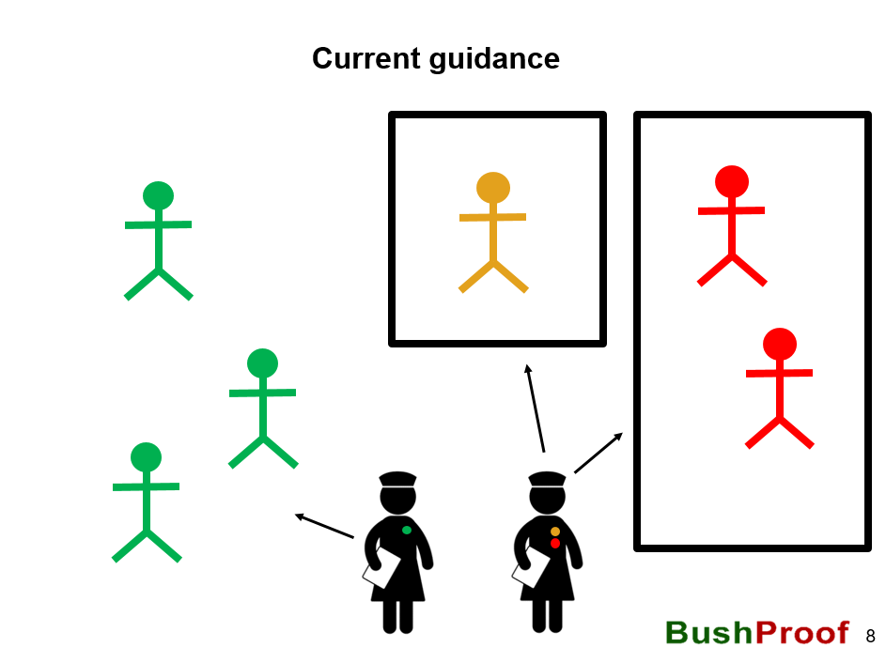

- The problem with this lies with asymptomatic and pre-symptomatic transmission. If a resident or staff member has no symptoms they can still (a) have COVID-19 and (b) be infectious to others.
- This transmission can happen from staff members to residents, or vice versa, or resident to resident.
- Also, there is the chance that someone who is symptomatic might actually not have COVID-19.
- In the example below, we show the categorisation of staff and residents by symptoms (shown by colour), while showing those who actually have the virus to be carrying a small red virus. So here we can see that we have one asymptomatic resident who is carrying the virus (categorised as green though since they have no symptoms), one asymptomatic staff member who is also carrying the virus who has been allocated to work in the green areas, and one symptomatic carrier of the virus (red). All can give transmit the virus to other residents / other staff members / inanimate objects if they don’t perform obsessive hand hygiene, use PPE and other protocols. It shows that screening and taking action only based on symptoms, will not stop the virus, and that asymptomatic carriers are a serious risk for spreading the virus if we do not have measures to stop this.
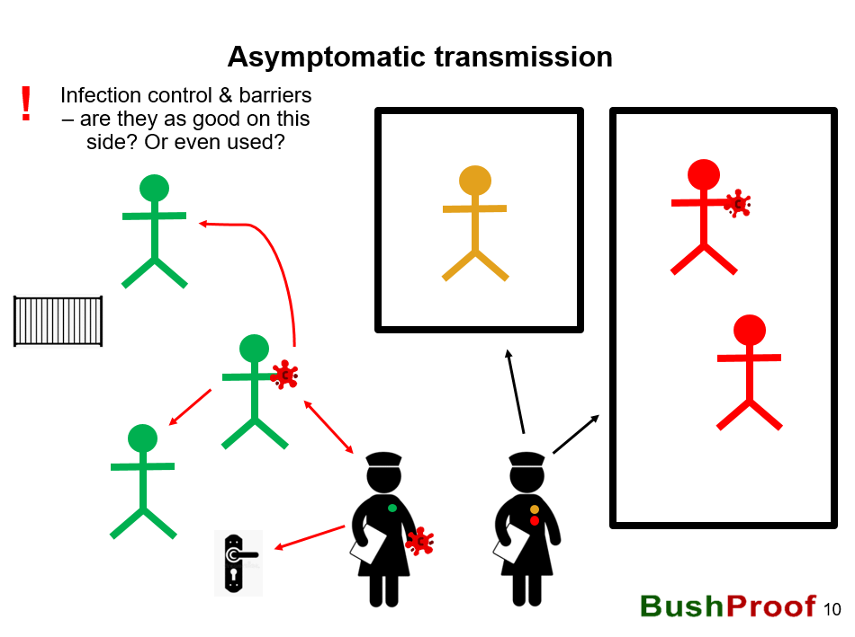

- If this is the case, how to stop it then? We therefore need to think of infection control in terms of barriers to transmission everywhere.
- This applies even for those people (staff and residents) who do not have symptoms.
- We also need to remember that the virus remains on objects. It’s not all about person to person transmission, actually it is as easy to transmit it via an object like a door handler or railing.
- In the example below, you can see some ideas for how to create those barriers – this includes hand hygiene every time you cross a zone, every time before and after you touch a high-touch object (like a door handle), by using PPE, and by minimising close contact. This is the basis of infection control outlined in this document.
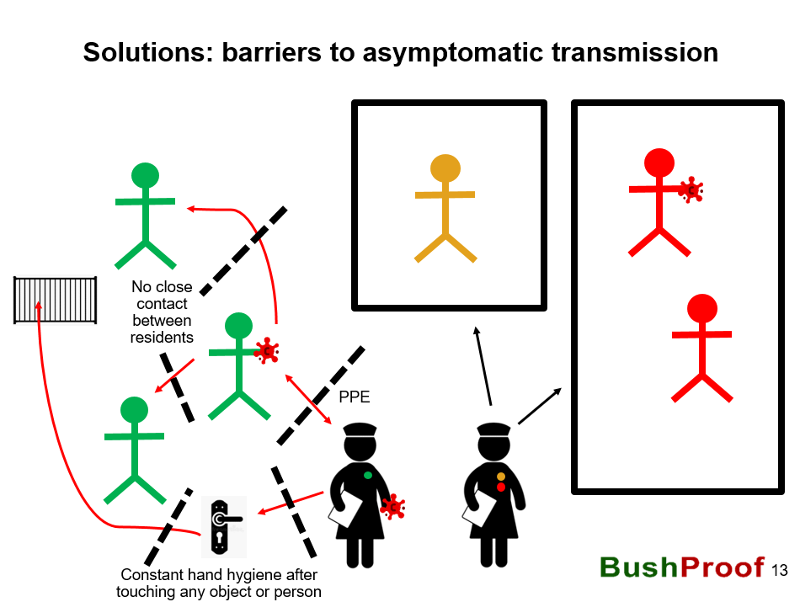

- Annex: Manual procedure to size a MVHR and / or HEPA air filtration unit
Below is a worked example for the manual decision-making procedure to size a Mechanical Ventilation with Heat Recovery (MVHR) unit and / or a HEPA air filtration unit for a communal room in a care home setting. The graphs come from the Excel decision tool where you can also enter some parameters and it will calculate it for you (available here: https://www.bushproof.com/?smd_process_download=1&download_id=1658).
To use the tools manually:
- Measure the room volume in metres (i.e. width x breadth x height). For example, a room floor area might measure 8 m x 8 m, and with a ceiling of 2.4 m would mean a volume of about 154 m³. Looking at the options in the table, take the room volume that is just below your calculated volume (in this case 150 m³).
- Note that the colour coding in the tables only indicates usefulness in general for a care home. Green indicates that denotes higher flow rates, occupancy and occupancy times, whereas the red end of the scale indicates that ventilation capacity can only support low occupancy and low occupancy times.
- Check occupancy time against air change rate. Using the first table, check along the third line down (the one for 150m³ room volume). For example, if you decide on 3 hours (outlined in red below), it means you would need 2.5 air changes per hour to take place (indicated by that column). The colour is yellow meaning that probably it will be sufficient in terms of useful time and numbers for a care home environment.
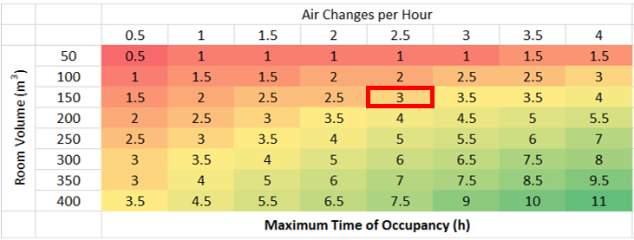
- Check occupancy numbers against air change rate. This should be the worst case scenario (e.g. both residents and staff when the room is fully occupied on Christmas Day). For example, you might normally have a maximum of 14 residents using that room in the past. Using the second table, again check along the third line down (the one for 150m³ room volume) and the column showing the air change rate from the previous step (2.5 air changes per hour) – here we can see that a maximum of 10 people (outlined in red below) would be allowed at one time, including staff and residents. This means you have to reduce your occupancy to that as the maximum level (e.g. if you normally have 3 staff circulating, only 7 residents would be allowed). Note that in the tool, this has been calculated as the more conservative result after considering both social distancing (based on an area per person) and air flow rate according to accepted norms (in terms of pollutants such as carbon dioxide) – here we see that increasing air change rate will not make a difference because the room area is the critical factor (i.e. social distance predominates).
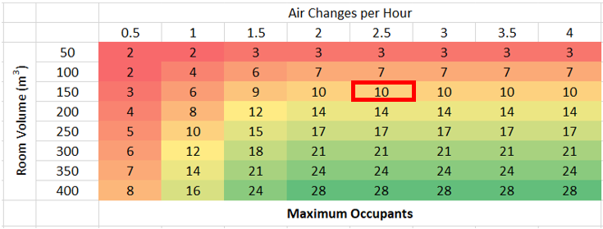
- Check the required total flow rate. Using the third table, again check along the third line down (the one for 150m³ room volume) for the air change rate from the previous step (2.5 air changes per hour). In this case we can see that at least 375 m³/hour would be needed as the total combined flow rate for all devices (outlined in red below).
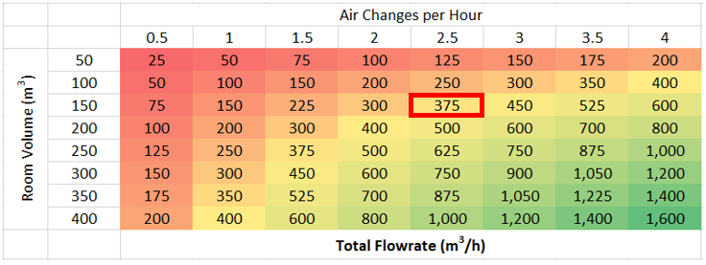
- Choose a ventilation unit first – if you decide to go for a larger MVHR unit, you will have a good choice on the UK market. If you prefer a single room MVHR unit, there will be less choice, and in this case you will find a separate tab for these within the Excel tool that show what your options are in terms of cost and performance – for single room units we would recommend you use one designated either ‘recommended’ (green) or ‘caution’ (orange), and device flow rates are shown in columns G and H. Let’s take the example that you decide to install just one single room unit (e.g. the Vaventis Freshr) – the flow rate in practice may not be the maximum the unit can do, perhaps in this case about 100 m³/hour.
- Supplement the remaining flow rate using a HEPA air filtration unit in order to meet the total air flow required. Total required flow in this example was 375 m³/hour, so once you subtract the ventilation capacity (100 m³/hour) that leaves 275 m³/hour that must be met by a HEPA air filtration unit. For this there is another tab within the Excel tool with some examples originating from a separate calculation tool developed by Harvard University and the University of Colorado-Boulder (https://tinyurl.com/portableaircleanertool). Here we would take the second option (340 m³/hour), or we could also look around for another one from a UK supplier that would be closer to our target flow of 275 m³/hour – the main thing is that it will cover at least the remaining flow, and that it uses only HEPA filters.

See page 5 from: PHE (2020) Preliminary report from the Joint PHE Porton Down & University of Oxford SARS-CoV-2 test development and validation cell: Rapid evaluation of Lateral Flow Viral Antigen detection devices (LFDs) for mass community testing. https://www.ox.ac.uk/sites/files/oxford/media_wysiwyg/UK%20evaluation_PHE%20Porton%20Down%20%20University%20of%20Oxford_final.pdf
For an update on where the UK is with rapid tests, see: Wise, J. (2020) Covid-19: Which rapid tests is the UK pinning its hopes on? BMJ 2020;371:m3868. Available here: https://www.bmj.com/content/371/bmj.m3868
See: Garrido-Molina, J.M. et al (2020) Disinfection of gloved hands during the COVID-19 pandemic. J Hosp Infect. 2020 Sep 16;107:5–11. https://www.ncbi.nlm.nih.gov/pmc/articles/PMC7494495/
Kampf, G.; Lemmen, S. (2017) Disinfection of gloved hands for multiple activities with indicated glove use on the same patient. J Hosp Infect. 2017 Sep;97(1):3-10. https://pubmed.ncbi.nlm.nih.gov/28648454/
Gao, P. et al (2016) Effect of multiple alcohol-based hand rub applications on the tensile properties of thirteen brands of medical exam nitrile and latex gloves. Journal of Occupational and Environmental Hygiene, 13:12, 905-914. https://www.tandfonline.com/doi/pdf/10.1080/15459624.2016.1191640?needAccess=true
For an article about visitor pods, see: https://www.carehome.co.uk/news/article.cfm/id/1630709/visitor-ban-care-home-visitor-centres-safe-clean
See: https://www.gov.uk/government/publications/visiting-care-homes-during-coronavirus/update-on-policies-for-visiting-arrangements-in-care-homes
Department of Health (2016) Health Technical Memorandum 01-04: Decontamination of linen for health and social care - Management and provision. London, UK: Department of Health.
Department of Health (2009) JLA Ltd – OTEX Laundry System: Rapid Review Panel (Recommendation 1). London, UK: Department of Health.
NHS Executive (1995) HSG(95)18 – Hospital laundry arrangements for used and infected linen. London, UK: NHS Executive. Note: chlorine should only be used on white linen as it can bleach coloured textile. It should not be used on fabrics with fire-retardant or other specialist coatings, and should not be used at temperatures above 50°C to avoid damage to the linen.
https://www.cdc.gov/coronavirus/2019-ncov/hcp/ppe-strategy/decontamination-reuse-respirators.html
British Healthcare Trades Association (2012) Protect, Rinse and Dry: BHTA guidance on the care, cleaning and inspection of healthcare mattresses. London, UK: British Healthcare Trades Association.
NHS (2020) Uniforms and workwear: guidance for NHS employers. London, UK: NHS England.
Royal College of Nursing (2020) Uniform and workwear guidance. London, UK: Royal College of Nursing.
For more information see: RCPCH (2016) Every breath we take – the lifelong impact of air pollution. Report of a working party. Available here: https://www.rcplondon.ac.uk/projects/outputs/every-breath-we-take-lifelong-impact-air-pollution
Passivhaus Trust (2020) The case for MVHR. April 2020. Available here: https://www.passivhaustrust.org.uk/UserFiles/File/research%20papers/MVHR/2020.04.27-The%20Case%20for%20MVHR-v7.pdf

