Care Homes Strategy for Infection Prevention & Control of Covid-19 Based on Clear Delineation of Risk Zones

Version date: 30th June 2020

Written by:
Eric Fewster, BA, MSc, C.WEM, MCIWEM, CEnv, Independent Water & Environmental Manager, Salford, UK
With contributions / review from:
Dr David R Tomlinson, BM, BSc, MD, University Hospitals Plymouth NHS Trust, Plymouth, UK
Jean-François Fesselet, MSc, WatSan Unit Coordinator, Médécins Sans Frontières, Amsterdam, The Netherlands
Dr Sarah House, BEng, DIS, MSc, D.Litt, CEng, MICE, C.WEM, FCIWEM, Independent Water Sanitation & Hygiene (WASH) Consultant / Public Health Engineer, Leicester, UK
Dr Michaël R Laurent, MD, PhD, Geriatrician, Imelda Hospital, Bonheiden, Belgium
Adelina Comas-Herrera, MSc, Assistant Professorial Research Fellow, Care Policy & Evaluation Research Centre (CPEC), London School of Economics & Political Science, UK, Editor of LTCcovid.org
Dr Muh-Yong Yen, MD, Director, Department of Diseases Control & Prevention, Taipei City Hospital, Taiwan
Dr Jonathan Schwartz, PhD, State University of New York at New Paltz, USA
Alison Criado-Perez, RN, DTN, Rutland, UK
Christopher J Peskett, BA, RN, CTN, Norwich, UK

The author and reviewers collectively have a mix of experience from medicine/health, care homes, water/sanitation/hygiene, outbreak infection prevention & control (specifically from Ebola, SARS, Cholera, Lassa Haemorrhagic Fever, Tuberculosis and Diphtheria outbreaks) and emergency response.
Disclaimer: note that contributions / review by authors or contributors does not mean endorsement by the institution they work for.
If anyone has found this document useful and is using part of it in some capacity, we would appreciate to hear from you. For any questions, comments or suggested changes, please contact:
Eric Fewster, ericfewster@bushproof.com, +44 7814 788 846
This document continues to be subject to modification, given new evidence and information that comes in.
Revisions:
Date | Section | Revision
17th April 2020 |  | Original online
18th April 2020 | 2 | Clarity added on symptoms, and unreliability of symptoms-based screening
18th April 2020 | 11, 18 | Clarification that 0.1% and 1,000 ppm are the same
20th April 2020 | 11 | Removed ‘other considerations’ section on copper tape
20th April 2020 | Title page | Added qualifications
20th April 2020 | 18 | Clarification on accuracy required for weighing out chlorine
21st April 2020 | 1 | Added up to date paper on zoning by Schwartz et al (2020) and Yen et al (2020), also added text around less-than-ideal conditions of promoting IPC in care homes using our methodology, added ‘other options’ section in
21st April 2020 | 4, 9 | Expanded on staff allocation info, and info on masks for staff
21st April 2020 | 15 | Added a bit on observing hygiene in staff zone
22nd April 2020 | 15 | Added PHE and CDC guidance on return to work, with links
29th April 2020 | 2 | Modified & added layout variations, added text on layout options, added info on long-shedders
29th April 2020 | 4 | Modified staff allocation text
29th April 2020 | 9, 12, 16 | Some modifications to recommendations around vacuum cleaning
29th April 2020 | Title page | Added contributors
11th May 2020 | 2 | Added symptom to list (loss of taste), reworded part on asymptomatic transmission, rejigged colour code in layout 1
11th May 2020 | 19 | Added new section to explain asymptomatic / pre-symptomatic transmission along with references
11th May 2020 | 6, 7 | Added reference to GPs or nurses as being possible visitors
11th May 2020 | 7 | Reworded section on isolation looking at pragmatic approach in longer term, added part on dementia, added details on elevators
11th May 2020 | 9 | Added link to facial hair and masks, info on re-use of FFP2/N95 masks, also training vid for PPE donning and doffing
11th May 2020 | 11 | Added rinse step before chlorination, noted not to store chlorine in basements
11th May 2020 | 14 | Link to signage zip file
11th May 2020 | 16 | Modification to advice for fans during heatwaves
11th May 2020 | 18 | Underlining of fact to add chlorine to water, not the other way around
11th May 2020 | 12 | Removed part about segregating red/amber and green waste externally
1st June 2020 | Title page | Added contributors
1st June 2020 | 1 | Added reference to barrier nursing, second webinar link, link to UK government guidance changed to refer to our mapping document, new WHO reference added, added need for outbreak pre-plan
1st June 2020 | 2 | Qualified the part about testing, suggesting 2 tests to confirm if negative
1st June 2020 | 5 | Added part about sharing communal items like books
1st June 2020 | 6 | Added entrance info if making visitor room
1st June 2020 | 7 | Added for those isolating to have dedicated commodes & opportunities for bathing, also giving residents the option to wear masks if they want, plus idea for visitor room
1st June 2020 | 9 | Added part about laminated portraits, use of masks by staff when away from the care home and option for residents to wear masks if they wish, and a note on FFP2/N95 re-use.
1st June 2020 | 10 | Made a note about dishwashers
1st June 2020 | 12 | Added part about clinical waste bags, tissues, paper towels, and leaving some waste for 72 hours if no clinical waste stream
1st June 2020 | 15 | Added part about loss of smell/taste, and wearing masks
1st June 2020 | 16 | Modified section title to be clear it was about aerosols, added advice for residents on sneezing/coughing, added carpet sweepers as option, mention on mask type for cleaners using vacuum cleaners
1st June 2020 | 17 | Modified
1st June 2020 | 19 | Added second webinar link
29th June 2020 | 3 | Added part about washing soiled hands with soap & water
29th June 2020 | 9 | Added info for masks with exhalation valves, modified part on research / evidence for masks, modified info & order of text around wearing masks and added fit/seal test info, added part on labelling and disposing of re-used masks
29th June 2020 | 11, 18 | Removed reference to combined detergent-disinfectant products until we can get more data on these
29th June 2020 | 11 | Added part about QACs
29th June 2020 | 19 | Added link to evidence base, added one reference in table

Contents
1. Introduction 5
2. Delineation of zones 8
3. Hand hygiene 13
4. Staff allocation & rotation in relation to zones 14
5. Use of equipment 15
6. Entrances: staff & patient flow 15
7. Isolation / quarantine / communal living 16
For residents with dementia and other challenging behaviours 17
8. Staff clothes from home / showering 18
9. Personal Protective Equipment (PPE) 18
Recommended PPE 19
Re-use of PPE 22
Donning & doffing 23
10. Food preparation / dishwashing 24
11. Chlorination / disinfection of items & cleaning of surfaces 24
PPE disinfection 24
Dishes 24
Surfaces 24
Notes on chlorine preparation 25
12. Waste 25
13. Laundry 26
14. Signage 26
15. Staff health 26
16. Residents’ rooms & aerosols 28
17. PHE reporting 28
18. Chlorine solution preparation 29
Safety 29
Types of chlorine 29
Procedure 29
19. Asymptomatic / pre-symptomatic transmission in care homes 31

- Introduction
Rationale for needing this document
Some people with a nursing background will be familiar with the two concepts of source isolation (barrier nursing) and protective isolation (reverse barrier nursing). The general UK Government guidance also uses the terms Standard IPC (SIPC) procedures, which are the basic everyday procedures for IPC, and Transmission Based Precautions (TBPs), which are additional procedures for outbreak situations. This strategy aligns with these concepts, but adds a few specific additional barriers for COVID-19, that are currently missing or not clear from the UK government IPC guidance.
There are now two webinars available online that explain the rationale for this document and its key contents:
- An introduction to asymptomatic transmission and overview of the strategy document, recorded on 23rd April: https://youtu.be/QNN9iTnnRH0.
- A review of asymptomatic / pre-symptomatic transmission, recorded on 25th May: https://www.youtube.com/watch?v=kbTifRj7rg4.
This strategy incorporates as much current UK government guidance as possible, while remaining consistent. We have undertaken a mapping of existing guidance in order to understand the strengths and gaps, and to show how it relates to our strategy and the rationale for where it differs:
Mapping of Govt guidance for IPC for COVID-19 in care homes:
https://www.bushproof.com/wp-content/uploads/2020/05/Mapping-Govt-IPC-strategies-for-COVID-19-in-care-homes.pdf
Our care homes strategy is based around a fundamental understanding of asymptomatic / pre-symptomatic transmission as a major contributor to the spread of COVID-19. Because of that, we stress strongly the importance of clear delineation of risk zones throughout the entire building, in order to reduce cross-contamination including from asymptomatic residents to whom ‘normal care’ might otherwise be given. This method of zoning (also known as ‘Traffic Control Bundling or TCB) is known to have greatly reduced infection within health care centres from previous SARS and Ebola outbreaks, and has been detailed here:
Yen, M.Y. et al (2006) Using an integrated infection control strategy during outbreak control to minimize nosocomial infection of severe acute respiratory syndrome among healthcare workers. Journal of Hospital Infection, Volume 62, Issue 2, February 2006, Pages 195-199. https://www.sciencedirect.com/science/article/pii/S0195670105001258
Yen, M.Y. et al (2011) Taiwan's traffic control bundle and the elimination of nosocomial severe acute respiratory syndrome among healthcare workers. Journal of Hospital Infection, Volume 77, Issue 4, April 2011, Pages 332-337. https://www.sciencedirect.com/science/article/pii/S019567011000530X
Yen, M.Y. et al (2020) Interrupting COVID-19 transmission by implementing enhanced traffic control bundling: Implications for global prevention and control efforts. Journal of Microbiology, Immunology and Infection. https://www.sciencedirect.com/science/article/pii/S1684118220300712
Schwartz, J. King, C-C.; Yen, M-Y. (2020) Protecting Healthcare Workers During the Coronavirus Disease 2019 (COVID-19) Outbreak: Lessons From Taiwan’s Severe Acute Respiratory Syndrome Response. Clinical Infectious Diseases, ciaa255. https://doi.org/10.1093/cid/ciaa255
We acknowledge that this knowledge on zoning comes from health care settings, not care homes, which have a vulnerable population living in close quarters. Therefore the strategy outlined in this document may not be ideal (i.e. where we have to deal with confirmed, suspected and healthy residents who are all present within the same building) and even with stringent controls, cross-contamination is a very real possibility given other constraints of staffing and PPE shortages.
However, this is the current situation that we find ourselves in. A recent paper adapting the zoning concept to long-term care facilities has been released, which has very similar guidance to this document:
Yen, M.Y. et al (2020) Recommendations for protecting against and mitigating the COVID-19 pandemic in long-term care facilities. Journal of Microbiology, Immunology and Infection. https://www.sciencedirect.com/science/article/pii/S1684118220300979?via%3Dihub
More recently on 21st May, WHO released updated guidance for infection prevention and control in long-term care facilities within the European region, which now recommends our zoning strategy:
WHO (2020) Strengthening the Health Systems Response to COVID-19. Technical guidance #6: Preventing and managing the COVID-19 pandemic across long-term care services in the WHO European Region.
http://www.euro.who.int/en/health-topics/Health-systems/pages/strengthening-the-health-system-response-to-covid-19/technical-guidance-and-check-lists/strengthening-the-health-systems-response-to-covid-19-technical-guidance-6,-21-may-2020
This strategy also attempts to add some more pragmatic detail for certain elements. For example, how to practically re-purpose PPE as suggested here:
WHO (2020) Rational use of personal protective equipment for coronavirus disease (COVID-19) and considerations during severe shortages: Interim guidance. https://apps.who.int/iris/bitstream/handle/10665/331695/WHO-2019-nCov-IPC_PPE_use-2020.3-eng.pdf

Intended audience
In general, there needs to be one designated staff member in each facility who is the lead for infection prevention and control. This document is meant for that person and/or the care home manager.
It has been written for the UK context to help people both plan for and implement effective infection control, in order to minimise risks to vulnerable people living with the homes and the staff who care for them, but it should also be useful for other country contexts.
We realise there will be a whole range of different set-ups of care home depending on the level of care required (e.g. nursing, care, sheltered housing), so each which will need a context-based response. The idea here is for people to be able to use/adapt this document for their own context, yet doing so in the light of understanding about Infection Prevention and Control (IPC) through use of clear delineation of risk zones.
It is very important to pre-plan for an outbreak in your care home while you have the time to do so. Doing this will allow you to be able to act quickly and stop or minimise the spread right from the beginning once you get a first case, rather than having to get your systems in place and train your staff at the same time as responding. Develop a step-by-step plan for each element of the response, as outlined in this strategy and adapted to your particular context. Prepare signs, train your staff and develop simple briefings, ready for training of short-term agency staff who you may call on. If possible, also plan in training drills to build confidence of your staff in handling the situation.
Preferred options
There are other options that allow an increased level of compartmentalisation rather than dealing with various levels of risk within one facility. These would be preferable options for government to consider in order to reduce the risk of infection in care homes, and include ideas like:
- Total shielding: since infection comes from outside, the safest way is where staff would move in to live in the care home, and all contact with outside is stopped.
- Discharging residents (both those with and without Covid-19) from hospitals to specific amber residences (the Department of Health & Social Care document, dated 15th April and called ‘Our Action Plan for Adult Social Care’, has this as an official option).
- Transferring all confirmed or probable cases to specific red residences (although this will not deal with asymptomatic residents).
Fundamental aspects of Infection Prevention & Control in care homes settings
- Understanding that asymptomatic / pre-symptomatic transmission is a major contributor to the spread of Covid-19 in care homes, where the source of this transmission comes from outside (mostly via staff and returning residents from hospital, but also visitors)
- Clear delineation of zones of risk for the entire building, differentiating between contaminated & clean, which is reinforced through staff allocation & rotation
- Hand disinfection for all points between risk zones (even where gloves remain on)

- Delineation of zones
Having the care home divided into clearly marked risk zones should greatly help reduce infection. Experience from the SARS outbreak suggested that when staff worked in a given area without any designated zones of risk, they developed a false sense of security when they were working away from SARS patients. Likewise, wearing PPE also may have led to a false sense of security.
For care homes, we suggest dividing the entire care home building(s) into clear zones as follows:
 | Green zone |  | Amber zone | Red zone
Activity | Anything on the side before putting on full PPE – e.g.  Stores  Pharmacy  Offices  Shower  Changing room  Food preparation  Staff eating area  Dish washing | Residents’ rooms (no symptoms, resident in situ more than 14 days) | Residents’ rooms (no symptoms but returned from hospital within last 14 days)  Access areas / elevators  Entrance for essential visitors / returning residents  Chlorine / cleaning preparation / PPE disinfection / drying area (door to terrace, lines outside?)  Nursing station / drugs cupboard or trolley  Laundry  Toilets for staff | Residents’ rooms (for people who have symptoms)  Disinfection / storage area for shared equipment (e.g. thermometers, BP machine, hoists, commodes – see section 5 below)  Temporary waste disposal area for waste from amber / red rooms  Dish soaking from red rooms  Dirty laundry holding area from red rooms
PPE | Mask only | Full PPE | Full PPE (since it is a quarantine zone = asymptomatic hospital returnees) | Full PPE

Exactly how the existing structure(s) can be demarcated into these zones will vary greatly between different care homes, and will depend on the existing physical layout and space. In principle, the more you can separate out the green, amber and red zones, the easier the infection prevention and control should become. However there will be local constraints in many cases, so the idea of this document is to introduce the overall approach in order to allow you to adapt it to your context as best you can. Below we suggest a few options that are visualised as layouts on the following pages:
- Zones separated on different floors within the same building (greater separation)
- Zones separated on the same floor within the same building (less separation, but this is probably the actual situation at the outset, and/or where physical space is very limited, and/or residents cannot leave their rooms for whatever reason)
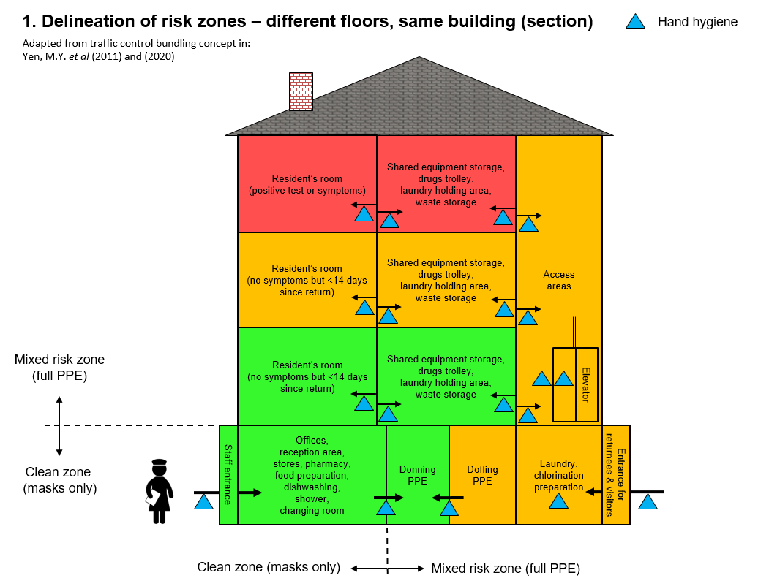
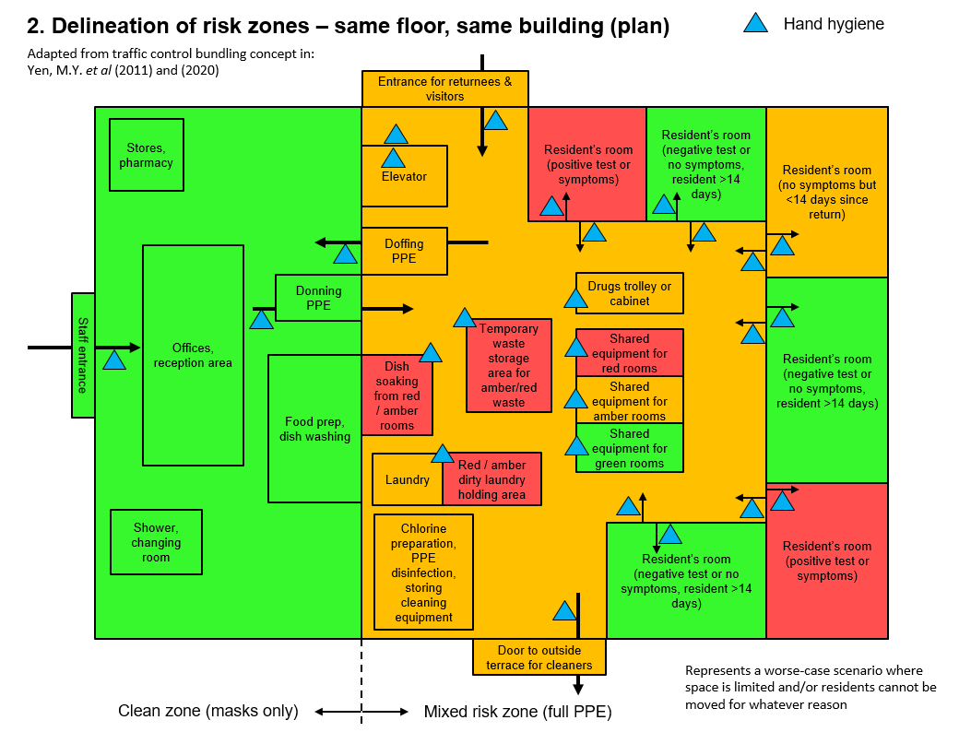
You will need to map your care home and decide which areas are which zone, and where the PPE on/off area(s) will be.
To do this, you need to decide which resident should be allocated to which zone (meaning zones can change over time, depending on illness or recovery). Allocating residents to zones is a challenge however, since there is growing evidence of asymptomatic and pre-symptomatic transmission of Covid-19 in care homes, and that symptom-based screening can fail to identify around half of residents with Covid-19. This means for example, that you might assume a resident is not infected because they appear healthy and have no obvious symptoms, which puts them in the green zone – but it could be that in reality they have Covid-19 and are infectious (note: asymptomatic or pre-symptomatic people are very infectious with this version of coronavirus (SARS CoV-2) compared to the previous version from 2003 (SARS CoV-1), since the virus load peaks 5 days earlier with SARS CoV-2, which is anywhere between 1 and 6 days before symptoms appear). For an explanation about asymptomatic transmission in care homes, see section 19 in this document, as well as the explanation in this webinar (starting at 9 mins into it): https://youtu.be/QNN9iTnnRH0.
This means that we cannot rely only on symptom-based screening, and underlines the crucial importance of the zoning approach for the entire building, combined with other stringent infection control measures across all zones.
Testing of all residents (including those with no symptoms) will therefore be a very useful thing to do as often as possible, but again currently we cannot rely only on testing due to the lag between test and results (currently at least 48 hours) and the possibility of false negatives. Therefore it brings us back to the critical importance of zoning and other stringent infection control measures.
Deciding which residents are in the red zone:
- Any resident with a positive test result. Note that these residents should remain as red zone for at least 14 days, after which time ideally 2 tests would be done to check their status. A test will be a good idea to confirm, since recent research has shown that a proportion of positive cases can shed the virus for longer than the standard 14 days (a case study from a London care home found 3 out of 20 positive cases were still shedding viruses up to 4 weeks later – see 32 minutes into this presentation: https://covid.joinzoe.com/post/webinar-covid-research). These so-called ‘long-shedders’ might be more common in some older people who may not be able to develop immunity responses as easily/quickly as younger people.
- Any resident who is known to have been in contact with a confirmed case of Covid-19 (this could be someone who had contact with an essential visitor, or a staff member that got tested positive)
- Without doing a test, symptoms are nevertheless one method we have to help decide whether a resident is more likely to have Covid-19 (and therefore be categorised as red zone). Daily health checks and close awareness / monitoring of any health changes in residents can look for the following indicators in order to make a decision:
Symptom | When it indicates a possible issue
Body temperature (use ear thermometer & plastic cone) | If fever of > 37.8 degrees (but note: elderly often have no fever)
Cough | Persistent cough
Shortness of breath
O₂ saturation | >5% absolute drop in O₂ saturation
Sore throat
Loss of sense of smell
Loss of sense of taste
Sniffing
Muscular / joint pain
Headaches
Nausea / vomiting
Diarrhoea
General malaise
New onset or worsening confusion | Care home staff with detailed knowledge of residents are well-placed to intuitively recognise these subtle signs
Loss of appetite / weight loss
Conjunctivitis
Skin rash
Apathy / drowsiness

Deciding which residents are in the amber zone:
- Any returning resident without symptoms needs to be classed as a ‘suspected’ case, and need quarantine for 14 days. After 14 days since returning, their room can become green.
Deciding which residents are in the green zone:
- Any resident with a negative test or no symptoms AND if resident in-situ over 14 days.
You will need a centralised recording system to record residents’ status. This itself can be a challenge, since pens / paper cannot be taken across from the green office zone to the PPE zone. So there needs to be a mechanism of recording daily colour codes for different rooms that can be printed / written in the office zone, but seen in the PPE zone (e.g. lists taped to a dividing window). Whatever recording system is used, for the zoning concept to work it needs to be very clear every day which room is green, amber or red (alerts relevant staff whether or not to go in).
The challenge in a care home is having a mix of amber / red / green areas after donning (putting on) PPE. Combined with the likelihood of having asymptomatic residents or staff, this complexity means that we must be obsessive about preventing cross-contamination between residents between zones, in order to keep uninfected residents safe. This means:
- Dedicating all staff (including cleaning staff) to serve only certain zones, with separated rotations, and ideally keeping the same staff allocated to each zone over time (see section 4 below).
- Constant hand hygiene when crossing zones (e.g. on both sides of each door, or near buttons outside/inside an elevator, see section 3 below).
- Having a rational plan for the use of elevators, which are a risk area for transmission. Some ideas include:
  - If there is more than one elevator, consider having one dedicated to red / amber residents or any potentially contaminated items (e.g. waste / laundry), and the other dedicated to green residents / staff.
  - If there is only one elevator, consider having set times in the day when higher-risk people or items are transported, after which the elevator can be cleaned.
- After exiting a red / amber room avoid touching handrails / walls / items before doffing (taking off PPE) area.
- During a rotation where staff will visit more than one resident’s room, staff must change PPE between rooms, and this should be in dedicated PPE changing areas (see section 9 below). This is because using one set of PPE and then going with it to a second room will introduce risk of contamination (e.g. it is possible that you will need to lift / touch residents or other items, meaning that a contaminated apron / gown from the first room can come into contact with the person / item being lifted).
- In the case that a staff member has to handle / lift a resident when they are outside of their room (e.g. in the garden and fell over), then PPE should be changed after the handling procedure.
- Hand hygiene
Hand disinfection needs to happen at multiple places, many times a day:
- Between handling patients, WHO recommends changing gloves and performing hand hygiene in between (usually with an Alcohol Based Hand Rub).
- Apart from this, based on experience from the SARS outbreak, we also recommend performing hand disinfection even when gloves are on, in order to reduce transmission of the virus from / to different surfaces in the environment. This is because transmission of the virus happens not only from infected patients to your gloves, but also from various surfaces to your gloves as well. So the routine is to disinfect-touch-disinfect. For example when going into a room, disinfect hands, open door to patient’s room, disinfect hands once door is closed. Or when getting medicine from medicine trolley, disinfect-get meds-disinfect.
- Hand hygiene is also done when you change out of your PPE – but here also note that where long-sleeved gowns are not used, you should also wash any bare arms with soap and water.
- Note that if hands are visibly dirty / soiled, then it is better to use soap and water rather than alcohol gel.
The type of alcohol-based hand products should contain at least 70% alcohol. Alcohol-based foams are also available (maybe more available right now) and more suited for areas where residents have alcohol dependencies.
Vivid signage at each hand hygiene point will help to remind (see section 14 for ideas).
These hand disinfection points need to be located at all points between risk zones (see zone layout), such as:
- PPE donning (putting on) area
- PPE doffing (taking off) area
- Both sides of every resident’s door
- At the storage point of shared equipment items
- At the drugs trolley
- Outside each elevator door on each floor, and inside the elevator
- At all entrances / exits to the building
- At any temporary waste holding area
- At the laundry
- Staff allocation & rotation in relation to zones
To reduce risk of cross-infection, allocate staff to certain zones (including cleaning staff) and try to have as little interactions between the different groups of staff as possible:
- Staff allocation:
  - The ideal situation is where staff can live in with residents from one zone, and where there is no contact between staff or residents and the outside world (some care homes are doing this, and would probably be the only reliable way of caring for people with dementia).
  - For other situations where staff come and go every day:
    - Staff should be allocated to either work in red, amber or green zones.
    - Ideally staff should continue to work in those zones every day when they come to work (rather than swapping over).
    - Try to maintain as much separation as possible between staff groupings at all times (e.g. even when back in the shared green office zone, groups could have separated spaces for activities).
- Staff rotation: where staff have been allocated to certain zones (e.g. one group allocated to the green zone, another group to amber, another group to red), staggering staff shifts by zone might also help contribute towards avoiding cross-contamination between staff (since there would be less proximity during work duties). So for example, one hour could be set aside for green staff shift, then one hour for amber staff shift, and so on). However, we acknowledge that in reality this might be impractical.
- If there are not enough staff to allocate shifts solely for amber or red rooms, then where staff must access both amber and red rooms in the same rotation, they should start with amber rooms first, then red rooms (but with PPE change between each individual room).
- In cases of very limited staff (e.g. one cleaner in small care home), cleaning by rotation using the same principle would be the way forward – e.g. first shift cleaning green rooms, next shift cleaning amber rooms, next shift cleaning red rooms (but with PPE change between each individual room).

- Use of equipment
Cross-contamination risk from equipment needs to be eliminated, both from the green zone (office area) to other areas (the zones after PPE donning), but also between green / amber / red rooms. Some ideas to help include:
- Banning use (and carrying of) personal mobile phones by staff when in full PPE – the temptation / risk is too great to respond to calls and messages while not performing hand hygiene both before and after touching the phone. Leave these phones with personal effects in the green zone office area (you will need somewhere for staff to lock valuables in).
- Where bleeps or phones are required for work within full PPE areas, these then need to be allocated to those areas and left there. Don’t bring these items back to the green office zone. Where computers are required in the PPE zone, these should also be permanently allocated to that side.
- Simple things like pens and paper should also not cross to and from the green office zone. Have a stock of ‘dirty’ pens and paper, then when you need to transfer notes to office staff, tape the paper on the windows of the PPE zone, then copy the items behind the window of the clean zone.
- Any equipment needed for residents should be kept within the PPE zone, and should not come back to the green office zone.
  - Where there are enough supplies, the ideal situation is that some equipment is kept in rooms for individual use (e.g. saturation meters, thermometers).
  - Some equipment will need to be shared between rooms though (e.g. BP machine, hoists, commodes, cleaning equipment like mops and vacuum cleaners) – in this case:
    - Separate out and store for each zone equipment that is shared (green, amber and red) in separate dedicated storage areas (i.e. don’t use red equipment in a green zone).
    - Wash and disinfect each item after each use, regardless of which zone it is for (see section 18 below).
- Another point is that residents should not immediately share books and other items that are usually communal – the safest way will be to leave the items in quarantine for 5 days between uses (this give enough time for any virus to die off).
- Entrances: staff & patient flow
Returning residents or essential visitors (e.g. family members for terminally ill patients, district nurses or GPs) may introduce COVID to the green zone. So if possible, dedicate one entrance for staff (into green zone), and a second entrance for everyone else directly into the amber zone.
If a visitor room is created (see section 7), this will need a separate entrance to the outside, rather than an entrance from somewhere within the building.

- Isolation / quarantine / communal living
All residents should be assumed as vulnerable and in need of shielding, therefore:
- Each resident must have own room / bathroom.
- In the unavoidable case of shared / multiple occupancy rooms, and / or shared bathrooms:
  - Residents sharing rooms should be grouped according to: asymptomatic, suspected or confirmed (i.e. symptomatic residents should not share with asymptomatic residents, and suspected cases should not be grouped with confirmed ones).
  - Residents isolating in their own rooms but sharing bathrooms:
    - For toilet purposes, ideally a dedicated commode (and bed pan / urine container as appropriate) would be most appropriate in order to reduce the need for those in isolation to keep coming out of their rooms.
    - Keep in mind that just because residents are in the red and amber zones, this should not mean they receive less care as a result, especially for issues around hygiene and dignity (e.g. bathing – there have been cases where people in isolation had not showered for weeks in the case where there were communal facilities because of concerns over rules for isolation). Residents in isolation are already in a stressful position, and not having access to basic hygiene will only add to that. For showering, there should always be a way to work around a situation (e.g. allocating certain shared bathrooms as red or amber and disinfecting between uses).
- Isolation itself however is hard for residents, and since this situation will continue for many months, you will need to invent safe and risk-free ways for interaction. We would suggest two scenarios based on whether there are confirmed/suspected cases or not:
  - Where you have confirmed or suspected cases: isolate everyone in their rooms and have no social interaction, until 2 weeks have passed since the last case and/or everyone is tested negative. All meals should be taken in rooms, with no communal dining.
  - Where you do not have confirmed or suspected cases, you will still have the risk of transmission from asymptomatic or pre-symptomatic staff or residents. But in this case a pragmatic way forward in terms of isolation for the longer term will be to create ways of social interaction, but keeping in mind:
    - Internal social distancing must be enforced – this means no ad hoc internal resident to resident visiting or socialising where 2 metres distance cannot be met. Any areas where this cannot be guaranteed should be taped off.
    - Other ideas will exist to still allow internal interaction – for example one idea is to have tables with Plexiglas (clear solid acrylic) divisions so that residents can still chat in a semi-communal setting.
    - In addition it will be good to give the option for residents to use face masks if they wish to do so when accessing communal areas. We now know that transmission is greatly reduced by mask-wearing (see section 9), and also some residents may feel safer using one, yet we also realise that for many residents this will not be possible for various reasons. However the option should be there.
- No external visitors that have physical or close contact with residents if at all possible:
  - Exceptions might be an ‘essential visitor’ (meaning someone who is allowed to visit a terminally ill patient) or a GP / nurse doing rounds. In either case, a health check for visitors is needed on arrival (as per section 15) and full PPE should be worn by visitors, and the donning / doffing procedure supervised by staff before and after the visit).
  - For relatives of all other residents, some ideas to consider promoting include:
    - Online face time with relatives (but note if sharing a device, this has to be fully disinfected between uses if shared)
    - Facilitating visits but in a different way that does not carry the risk of residents receiving the virus from outside. Staff will have to be closely supervising these interactions to ensure that visitors strictly adhere to guidance. Some examples of ideas:
      - Allowing relatives to visit but remain outside a window.
      - In good weather, having a dedicated outdoor space where interaction can happen at a safe social distance. Visitors must wear masks (and ideally residents as well) since it is known that the virus can travel further than 2 metres and remain in the air, and how far it can go will depend on things like local wind conditions – so having a mask will reduce this risk dramatically.
      - Creating a dedicated visiting room with a Plexiglass (clear solid acrylic) wall that completely blocks physical access from one side to the other, yet allows people to talk but where residents are still shielded. In this case, this room should have a separate entrance directly from outside – this means the entrance should not be via the staff green zone, otherwise visitors risk contaminating that area, from where contamination can then be taken to residents by staff. Also visitors themselves should also be protected – this means visitors should wear masks and perform hand hygiene on entering and leaving, and any high-touch surfaces should be disinfected between visits (e.g. door handles, tables, chairs).

For residents with dementia and other challenging behaviours
To care for residents with dementia is admittedly one of the most challenging circumstances, and there are no easy answers on this. It is important to get right, since about large proportion of people in care in the UK have some form of dementia.
In general, what we do know is how the virus spreads, and close contact is one of those ways. So even if zoning / infection control is in full force, close contact to staff still carries risks since the virus can pass from someone with dementia to the staff member or vice versa, and then from this person with dementia to another resident. This risk will always be the case where there are staff and/or visitors from outside that will enter a facility on a daily basis (these will bring the virus in). Therefore the following could be ways forward:
- The best situation for those with dementia who require close contact, would be to have dedicated buildings/floors, where staff commit to live in with these residents and do not go home, and also where no outsiders are allowed in. However, this is very hard to implement, especially as some visitors will be needed (e.g. GPs) and in the longer term will probably not be sustainable.
- Where this is not possible, the only way then is to understand the risk and adhere as obsessively as possible to all the other infection prevention and control measures outlined in this document (e.g. strict hand hygiene, use of full PPE, making sure that the essential visitors are doing the same, etc.). In general, if the whole care home has all these measures strictly in place, then the overall risk for everyone in the care home is a lot lower than it would otherwise have been.
- Staff clothes from home / showering
- Have a changing room on site. On entering, change from home clothes to work clothes/shoes (be that a uniform, scrubs or other). On leaving, change out of work clothes/shoes before travelling back in home clothes.
- We recommend to launder work clothes at the care home (there may be more risk the further dirty clothes have to travel), doing so regularly at 60 degrees Celsius or higher, followed by ironing or tumble drying. Where this is not possible, clothes taken home need to be put in a cloth bag (that can be laundered with the work clothes without removing them from the bag) and then to put this into a plastic bag before being transported. The plastic bag used for transporting the clothes needs to be disposed of safely.
- Experience shows that having a staff shower facility in the care home before leaving greatly helps staff to feel safe before going home.
- Personal Protective Equipment (PPE)
PPE needs to be worn to all residents’ rooms (red, amber or green) and access areas to these rooms, as well as to any red / amber zones in the layout.
However in some cases it might not exactly be so clear cut when it comes to wearing PPE and preventing contamination – for example:
- Residents who are hard of hearing and outside of their room (e.g. some are allowed outside but not in groups): here it will be particularly good practice to wear a face shield and mask (which we are suggesting should be done for all patient contact), when communicating with them, since they may need to get closer than what is ideal to understand what is being said.
- Residents with dementia: person to person contact may be unavoidable in certain cases, so in these cases adhering to strict hand hygiene and changing into clean sets of clothes prior to contact, along with use of full PPE, might be the only way forward. Allocating live-in staff to that zone where there is no other contact with the outside world, might also be the only reliable option here.

Recommended PPE
Type of PPE that Public Health England recommends for staff in care homes is found here: https://assets.publishing.service.gov.uk/government/uploads/system/uploads/attachment_data/file/878750/T2_poster_Recommended_PPE_for_primary__outpatient__community_and_social_care_by_setting.pdf. This recommends PPE type according to type of task:
Full PPE for green, amber & red rooms after donning PPE
Full PPE (day-to-day activities) | Full PPE (for Aerosol-generating procedures (AGPs))
- Fluid-repellent surgical mask (FRSM / type IIR)  - Apron (disposable)  - Gloves (disposable)  - Eye protection / face shields | - Filtering face piece respirator (FFP2 / N95 without exhalation valve)  - Long-sleeved fluid-repellent gown / coverall  - Gloves (disposable)  - Eye protection / face shields

When choosing an N95 or FFP2 mask, make sure that these are the ones without exhalation valves – this is because if you are infected and wear a mask with an exhalation valve, the outgoing air is not filtered and there is a risk that you infect others. Some N95 and FFP2 masks (and most of the FFP3 masks) have exhalation valves, so you need to check.
Note that face shields might be more user-friendly for older people, especially those with dementia, since face and eyes can be more clearly seen. Another idea that helps residents recognise staff is to laminate a face portrait of each staff member which they can pin to their uniform – these should be wiped down and left at a designated point in the amber zone (rather than being brought into the green zone).
The guidance above is a basic minimum level. If it is possible, we would also recommend the following additional items where possible for care homes:
- Heavy-duty aprons (rather than disposable ones). This means that these could be disinfected and re-used, reducing ongoing PPE needs.
- A long-sleeved washable coverall or gown (for all work, not just aerosol-generating procedures). The rationale being that more of your uniform/scrubs can be protected compared with just using an apron, and in an ideal situation there would also be enough spares so that the coverall/gown could also be changed when PPE is changed, instead of continuing the whole day in clothes/uniform that might have been contaminated (outside of the area that had been protected by the apron).
- Heavy-duty rubber gloves (for cleaners). Again having a stock of these means they can be disinfected and re-used.
We realise that PPE stocks will be limited in many places. Some things you can consider to help this situation include:
- Disinfecting and re-using certain types of PPE, which can increase availability (see below).
- Ideally we would change full PPE between each resident, since we don’t know for sure if residents in one zone are all non-infectious even if they don’t have symptoms. However, circumstances may well dictate that we have to ration PPE, in which case changing only part of the PPE between each resident might have to be the way forward. The question then is which part of the PPE should be changed after each resident, and which could be used for a ‘session’ or shift (i.e. 2 – 6 hours). Logically, cross-contamination where PPE is not changed between every resident will mainly come from surfaces that get touched – this means the gloves, aprons and what you wear under the apron such as uniform/scrubs. In contrast, the mask and eye protection are less risky as long as you (or others) don’t touch/move these. The challenge is to take off and put on certain items of PPE while keeping mask and eye protection in place, since you don’t want to cross-contaminate items, and since you must deviate from standard donning protocols. So therefore where PPE stocks are low, you will probably end up concentrating your efforts on only:
  - Changing gloves between each resident.
  - Changing aprons at the same time, but note that this will be more difficult due to the doffing and donning routine (i.e. having to put apron over head while mask/eye protection still on).
For cleaners who carry out vacuum cleaning, we recommend they use the higher grade FFP2 / N95 respirator for aerosol-generating procedures (due to as yet unknown effect of circulation of viruses in exhaust air from a vacuum cleaner, but we do know that the virus can survive for hours in circulating air currents).
We recommend masks to be worn by all staff the whole day, even when not in full PPE (i.e. when in green office zone), and also when travelling to and from work (i.e. using public transport) – this is to prevent staff both getting infected (e.g. on public transport) and then giving infection to residents (when on shift). The reason for this recommendation is that it is now clear from recent research that airborne transmission is a risk from both droplets and aerosols, and that wearing a mask both reduces the risk significantly of someone who is infected from transmitting the virus, but also helps protect someone who is uninfected. The WHO therefore is now recommending widespread use of masks in public. The risk of transmission when masks are not used also exists from asymptomatic carriers – this risk increases when light activity is carried out (i.e. walking around, similar to what care staff would be doing), in closed spaces with more people present (i.e. communal areas, offices, meeting rooms), and where there is insufficient ventilation (i.e. where windows are closed, or where there is no mechanical ventilation system). For a review of the recent evidence around airborne transmission and the effectiveness of masks, there is a link on the care home document holding page: https://www.bushproof.com/care-homes-strategy-for-infection-prevention-control-of-covid-19-based-on-clear-delineation-of-risk-zones/.
A few things to keep in mind in general when wearing masks:
- If you need to talk, do this through the mask.
- If you need to take the mask off (e.g. to eat), remember that a mask should never be lowered to chin or put on the forehead, and it should not be taken off and deposited anywhere except either a bin (i.e. should not re-used) or a storage container (in the case of FFP2 / N95 masked that are re-used – see section on ‘Re-use of PPE’ below).
For respirators (FFP2 / N95) specifically:
- Remember that masks should cover both nose and mouth. For men who have facial hair, they should check the following diagram to see if it will work safely with a mask: https://www.cdc.gov/niosh/npptl/pdfs/FacialHairWmask11282017-508.pdf.
- A fit test is needed to first see which mask fits you, and then a seal test is needed every time you put on the mask. If the mask does not fit perfectly, you will not be protected from COVID-19 (and other respiratory diseases).
  - Fit test:
    - Everyone has a different shape of face, and one type of mask might fit better than another. So it is good practice to have at least two different makes of respirator mask available for people to use.
    - If a fit test cannot be done in the care home, then staff must be sent to a health centre, or a care home where staff have been properly trained to do this.
    - Note that a fit test should be redone if someone changes weight, or has dental work done (in the longer term).
  - Seal test:
    - Always check the instructions from the manufacturer about how to conduct the seal test, as it can vary according to the brand.
    - If doing a seal test for a respirator that you are re-using, ideally you should use gloves for doing this, then dispose of them and perform hand hygiene. If this is not possible then do very rigorous hand hygiene after putting it on.
    - Once fitted, check for leaks by covering the respirator with both hands and forcefully inhale and exhale. The respirator should collapse when inhaling and expand when exhaling, and no air leak between the face and the respirator should be detected. Refer to this WHO guidance regarding this: https://www.who.int/csr/resources/publications/respiratorsealcheck/en/
We also recommend masks to be worn by all residents where possible, as long as they can tolerate them:
- For symptomatic residents who are isolating, make sure they have access to masks, and ask them to use them when they leave their room if they are to use a communal toilet or shower room (and definitely do this when moving a resident from room to room).
- For asymptomatic residents who have access to communal areas, it would also still be best to give residents the option to wear a mask if they so wish. This is because masks are now known to both prevent spread of the virus from infected individuals, as well as protecting uninfected individuals from receiving the virus – therefore in the case that a resident or staff member is asymptomatic but does not know it, wearing masks will reduce the transmission risk overall for everyone. However, we realise that this will not be practical for many residents (e.g. those with forms of dementia), but it would still be good if the option is there for those that want it.

Re-use of PPE
Due to current shortages, it should be possible to re-use some PPE – see the following table.
Hot wash in 60 degrees Celsius or higher | Disinfect using 0.1% chlorine for at least 10 minutes | Dispose of, do not re-use | Re-use as last resort: allocate 5 items to each staff member, wear one each shift, store each one 5 days in labelled breathable paper bag at end of each shift, use them in order. https://www.cdc.gov/coronavirus/2019-ncov/hcp/ppe-strategy/decontamination-reuse-respirators.html
Some purpose-made medical gowns | Eye protection / face shields | Disposable latex gloves | Masks for AGPs (filtering face piece respirator, FFP2 / N95).
Scrubs | Heavy-duty rubber gloves (for cleaners) | Masks for day-to-day activities (fluid-repellent surgical mask, FRSM / Type IIR)
Coveralls / lab coats | Heavy-duty aprons | Disposable aprons

Regarding the information in the table above (last column) about re-use of masks as last resort – note that:
- This is not ideal by any means, but is at least a logical way to approach it, given what we know about the lifespan of this virus (storing it long enough, the virus dies off).
- But this is only considered a valid approach for the higher-grade respirators (FFP2 / N95).
- Although FFP2 / N95 respirators can be used for sessions (i.e. 2 – 6 hour shifts), depending on the number of shifts you might need to allocate more masks per staff member for this to work. The actual number to allocate to each staff member needs to be enough to allow 5 days between the use of each mask.
- A good labelling system needs to be in place to keep track of this. Note that you should never write on the mask material, but rather stick a label on the strap.
- Discard a mask if it is wet, stained, contaminated by body fluids (e.g. nasal secretions), damaged, or straps are loose. If the inside of the mask becomes contaminated by touching, discard it.
There are some alternative PPE options such as:
- Long-sleeved lab coats or work overalls instead of purpose-made gowns
- Construction type eye protection glasses (the type with extensions at side of eyes)
- Swimming goggles. Note: if using sealed goggles, these tend to fog up – however, experience from Ebola treatment centres showed that wiping the inside the lens first with wet wipes and allowing to dry before putting them on tended to help prevent fogging.

Donning & doffing
There needs to be at least 2 dedicated areas for PPE donning (putting on) / doffing (taking off), although there might be more than this. Key thing is that these should be separate / segregated areas (even if physically close to each other), and are specific places where PPE is put on or taken off (i.e. do not take PPE with you into the rooms). The space in these areas needs to be big enough to allow people to keep 2m distance (maximum people at any one time depends on space, maybe put a sign up on door stating this).
Donning & doffing needs to follow clear / strict protocols.
It is completely essential that staff have good hands-on training about how to put on and take off PPE without contaminating themselves (English may not be their first language, practical demonstrations will help).
- A good video on donning and doffing that has the appropriate hand hygiene steps can be found here: https://www.cdc.gov/coronavirus/2019-ncov/hcp/using-ppe.html.
- Hand hygiene is well-known as one of the most effective methods to stop transmission of diseases. For some visual examples that care home managers might even try with their staff as training, see this video clip (starting 20 mins in): https://www.youtube.com/watch?v=WeV_b8YM9kE&feature=youtu.be

Donning (putting on) areas should have:
- Bench/chairs
- Shelves for orderly arrangement of PPE
- Donning poster (note: depending on which PHE guide you are using, add a hand hygiene step at the start)
- Mirror
Doffing (taking off) areas should have:
- Waste disposal (labelled as washable / re-useable items, or non-washable / disposable)
- Sink with water & liquid soap (for washing bare arms between PPE changes)
- Doffing poster (note: if using PHE guide, add a hand hygiene step between steps 2 and 3, so after removing gown but BEFORE removing mask or eye protection – see our modified sign which is part of our signage zip file available here: https://www.bushproof.com/wp-content/uploads/2020/05/Signage-for-care-homes.zip. Rule of thumb: perform hand hygiene after each step of doffing).
- Mirror
- Experience from Milan shows that if there are staff available, having someone to help supervise doffing can add reliability to the process (and reduce possible infection).
- Food preparation / dishwashing
An additional precaution can be to take dirty dishes from red / amber rooms and process them separately (see section 11 below). For this, there needs to be a way to transfer dishes between the dirty areas and the kitchen, with the washing / soaking part taking place in the contaminated zone and not the kitchen itself. Where dishwashers are used in the kitchen, then you will need a separate area for washing with soap and water within the red or amber zones, before moving them to the area to put in the dishwasher.
- Chlorination / disinfection of items & cleaning of surfaces
Chlorine is needed for PPE disinfection, soaking of dishes, and cleaning of surfaces. Note: a dilution of 0.1% chlorine is often referred to – which is the same as 1,000 ppm or 1,000 mg/L – and to make this dilution correctly, see section 18 below.
Procedure in general is to:
- Wash with water / soap first
- Rinse off soap (important since chlorine will react with soap and therefore be less effective)
- Disinfect with chlorine second

PPE disinfection
PPE disinfection of certain items (e.g. heavy-duty gloves, eye protection, heavy-duty aprons) is done by washing with soap and water, rinsing, then soaking for at least 10 mins in 0.1% chlorine, then rinsing and drying.

Dishes
Where dishes are washed by hand, they should be washed with soap and water, rinsed, then soaked for at least 10 mins in 0.1% chlorine, then rinsed/dried.

Surfaces
Cleaning of surfaces needs to happen 2x per day if possible in amber / red areas. A rota/checklist will help keep track of what has been done. But you need to prioritise what to clean given your available time / staff resources:
- First priority needs to be given to any high-touch surface – these include bed rails, tables, door handles, any equipment with high touch surface.
- Where time allows, other surfaces that are touched (by hands) less often can follow – these might include hard floors and chairs.
Two options for what cleaning solution to use:
- Start with soap and water, then rinse with water, then disinfect with 0.1% chlorine. Chlorine is what both WHO and UK government guidance suggests.
- Use a detergent-disinfectant formulation, but only where the particular formulation and concentration conforms to EN 14476. This standard means it is "active against enveloped viruses" which includes coronaviruses, and therefore should be effective against SARS-CoV-2. However, to date there are limited studies that have looked at measuring direct effectiveness against SARS-CoV-2. (These formulations contain quaternary ammonium compounds (QACs), but note that the effectiveness specifically of the QAC known as Benzalkonium Chloride (BAC) is questionable).
When using chlorine, the smell can be quite strong, so opening windows to ventilate during the cleaning process will help.
Mop heads or cloths can be disposed of after use (if there is enough stock), or could be re-used in the same manner as re-use of PPE (i.e. washed with soap, rinsed, chlorinated).

Notes on chlorine preparation
For disinfection using chlorine, you need to have a way to create the necessary dilution of 0.1% strength, depending on type of chlorine used (see procedure in section 18 below) – this should be valid for either chlorine-only or detergent-chlorine products.
Important notes for chlorine use:
- Chlorine products emit a dense gas – best to have the mixing / storage area away from living areas and in well-ventilated space, but not in a basement where this gas will accumulate, and preferably within the amber zone and with link to outside (e.g. terrace for drying).
- Do not store next to fuel, heat sources, dry powder fire extinguishers, other chlorine types, nitrogen-containing compounds, oxidizers, or anything corrosive or flammable.
- Waste
Waste should be treated as clinical waste. You need to have a waste disposal system for red / amber waste versus green waste within the care home:
- Ensure you have clinical waste bags ready in each red or amber room.
- Ensure you have tissues and paper towels available in each room, as well as in communal areas.
- If you place waste temporarily inside the building before it is taken outside, then waste coming from red / amber rooms should be placed in a separate designated red storage zone.
- Pay particular care with the management of incontinence pads, or anything soiled with urine or faeces from all rooms. Studies indicate that the virus can be detected in stools for 5 weeks after the respiratory symptoms stop, so care needs to be taken when handling any contaminated items (here it is a precautionary principle, because we don’t yet know if the viruses are viable and can infect someone else).
- Empty contents from vacuum cleaners while wearing full respirators due to the risk of aerosolisation – any contents from equipment used for red or ambers zones should be put in the relevant designated waste areas.
- Red / amber zone waste should be disposed of as infectious clinical waste. It should be double bagged. In the case that there is no clinical waste stream, a solution can be to double-bag the waste and store it for 72 hours before putting it in the normal waste stream.
- Laundry
Laundry is done as normal on a hot wash (60 degrees Celsius or higher), followed by ironing or tumble drying.
In the laundry area, having separate areas for temporary storage of dirty laundry from red / amber zones will help create more awareness of risk from laundry staff when handling this laundry.
For soiled clothes or bedding from all rooms, pay particular care when collecting & transporting this to the laundry area. The laundry should be put into a red alginate bag, sealed and then loaded into the trolley for taking to the laundry area. Alginate bags can be put into the wash directly without being opened (since a part of the bag then dissolves during the wash cycle). In terms of infection control, the advantage of using alginate bags is that it will prevent staff handling the laundry from being at increased risk by not disturbing the viruses which are on the sheets or clothes – this is important, since one study of two people who were positive for the virus (but asymptomatic and who stayed in a room for only 24 hours) found that the highest concentration of the virus was on their bedding, even more so than the door handle and other regularly touched areas.
Do not shake clothes or bedding anywhere.
- Signage
Signs to help delineate zones & clarify levels of contamination. A zip file containing signs that you can adjust/print is available here: https://www.bushproof.com/wp-content/uploads/2020/05/Signage-for-care-homes.zip. Signs to consider printing include:
0.1% chlorine (for any containers containing it) | Donning area – Full PPE mandatory | Perform hand hygiene before AND after this door
Red / amber / green shared equipment storage point | Donning area – max … people at a time, do not enter if you can count more than this! | Don’t touch face with hands/gloves
Green waste | Doffing area | Returning resident / visitor entry
Red / amber waste | Instructions for PPE donning (putting on) | Returning residents / visitors please use other entrance
Temporary red / amber waste holding zone | Instructions for PPE doffing (taking off) | Staff entry

- Staff health
For staff deciding on when to come back to work, the most recent guidance from Public Health England is displayed on the flowchart below (summarised as if unwell, don’t come in to work but self-isolate for 7 days: https://assets.publishing.service.gov.uk/government/uploads/system/uploads/attachment_data/file/880057/Flowchart_for_return_to_work.pdf).
However, the latest guidance from the Centre for Disease Control and Prevention (CDC, 13th April 2020) provides additional detail regarding staff returning to work after testing positive yet without Covid-19 symptoms:
- “HCP [Health Care Personnel] with laboratory-confirmed COVID-19 who have not had any symptoms should be excluded from work until 10 days have passed since the date of their first positive COVID-19 diagnostic test assuming they have not subsequently developed symptoms since their positive test.” (https://www.cdc.gov/coronavirus/2019-ncov/hcp/return-to-work.html)
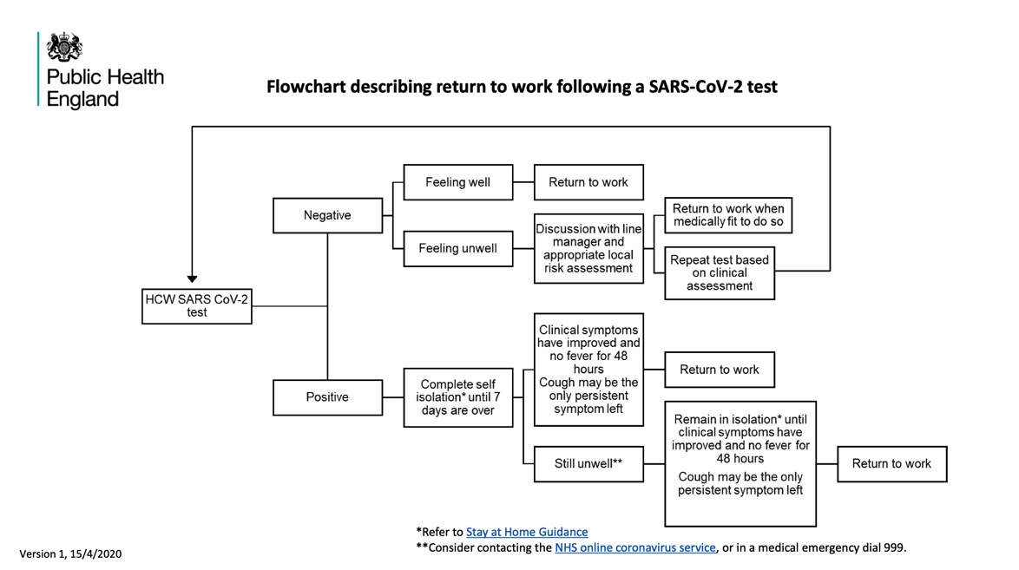
In addition, for those staff that are coming to work every day:
- Carry out a daily symptom checklist for staff before entering the care home (temperature, cough, loss of sense of smell or taste any gastro-intestinal symptoms).
- Remember that in the same way that residents can be asymptomatic and yet have Covid-19, staff can also be asymptomatic carriers and can infect other staff members. Keeping social distancing, wearing a mask and having the same procedure to hand hygiene (disinfect-touch-disinfect) is necessary, even in the ‘safer’ green zone.
- In addition, if regular testing of staff can be done (i.e. all staff including those with no symptoms) then this will help reduce the risk of transmission.
- Encourage staff to carry out their own zoning back at home.
- Encourage use of masks when travelling to and from work (i.e. using public transport) – see section 9.
- Residents’ rooms & aerosols
In general, we want to reduce anything that will generate aerosols as far as possible. Research now indicates that aerosols can travel much further than 2 metres and can also remain suspended in the air for some time. This means we need to try to minimize the amount of forced air movement which could exacerbate this:
- No fans allowed. In heatwaves however, this will be challenging. Where there are clear health and comfort consequences on the elderly if fans are not used, we suggest using air conditioners on low fan speeds and with oscillation turned off.
- Reduced vacuuming schedule for red or amber rooms (since it creates air flow through the filter and recirculation of particles, the effect of which is not known). Use dedicated hoovers for red or amber zones, and ensure staff using them use FFP2 / N95 masks. An alternative to vacuum cleaners could be to use carpet sweepers instead.
- The use of pressurised humidified oxygen, Entonox or medication via nebulisation are not considered to represent a significant infectious risk (see p.31 of the ‘COVID-19 - infection prevention and control (IPC) guidance’ document: https://assets.publishing.service.gov.uk/government/uploads/system/uploads/attachment_data/file/881489/COVID-19_Infection_prevention_and_control_guidance_complete.pdf). However, there are also other methods that are equally effective for giving medication to asthmatics or those with lung disease, but which do not use a nebuliser (e.g. a holding chamber).
- You also need to help residents know what to do if sneezing or coughing (in their rooms, as well as communal areas). This will be educate people to:
  - Cough or sneeze into their elbow, or to put their hand over their mouth when doing so, followed by hand hygiene.
  - To use tissues only once and then bin them.
- PHE reporting
When a suspected case develops, the local Public Health England contact should be notified. If care home staff are unable to contact this person, they can speak to their allocated GP, or delegated primary care health professional. The resident should be isolated until the 2 test results are available, but further contact with the allocated health professional may be required even in the context of a negative test (in view of the current high false negative rate) – for example, repeat tests after 2 – 4 days may be suggested in cases where there is a high pre-test probability of COVID-19 infection.
However, we know that anyone having no symptoms, or mild symptoms, can be shedding the virus (i.e. suspected case or not). This means that really all residents and staff should be tested as regularly as is feasible.

- Chlorine solution preparation
This guidance is for when you need to make up chlorine solution for disinfection of PPE or other items, and for disinfection of surfaces. Strength recommended (0.1% or 1,000 ppm) is based on current WHO guidance, and the method of preparation is in accordance to procedures from Ebola outbreak settings.
Note that 0.1% chlorine is the same as 1,000 ppm or 1,000 mg/L.

Safety
Several things to be aware of:
- Chlorine products emit a dense gas – best to have the mixing / storage area away from living areas and in well-ventilated space, preferably within amber zone and with link to outside (e.g. terrace for drying).
- Do not store next to fuel, heat sources, dry powder fire extinguishers, other chlorine types, nitrogen-containing compounds, oxidizers, or anything corrosive or flammable.
- Avoid skin contact, wear gloves & eye protection, do not inhale fumes.

Types of chlorine
You need to make up a 0.1% solution based on the type of chlorine base product you have on site. Your options might be:
- Granular chlorine 90% strength (borrowed from swimming pools – note for this type, that it should not be slow-dissolving type – it must all dissolve when you mix it)
- Granular chlorine 70% strength (commonly used in water treatment)
- Liquid bleach 5% strength (from stores – but not as good, since chlorine can have expired with liquid products)

Procedure
- Add the relevant amount of water to a bucket. Note: do not add water to chlorine, always add chlorine to water – this is to prevent chemical over-reaction.
- Slowly add a chlorine granules, the amount to add being determined by the % chlorine strength (see below) and the number of litres you are making up.
- Stir gently for at least 30 seconds.
- Disinfect items in this solution for at least 10 minutes before rinsing / drying.
- Items are normally drip-dried – this can be done outside on a line, or inside in a wet room or drying room.
Note that chlorine dilutions will deteriorate over time, especially once you are soaking multiple items in it. Therefore they should be changed regularly (at least once per day, but if heavily used and/or visibly dirty then twice per day).
How much chlorine to add for step 2 depends on the product you have. For different products, see table below:
Product | Amount to add per litre of water
Granular chlorine 90% | 1.11 grams
Granular chlorine 70% | 1.43 grams
Liquid bleach 5% | 20 ml

If your product has a different % active chlorine, you can adjust it to your product as long as you know the % active chlorine stated on the label. Make it based on the formula:
(1 x 100) / %
For example, if using 90% granular chlorine:
- (1 x 100) / 90 = 1.11 grams to be added for each litre of water. Best to use digital kitchen scales to measure out weight (keep these scales specifically for this task, don’t return to kitchen!).
- If you wanted to make up 20 litres, you would add 1.11 x 20 = 22.2 grams to the 20 litres of water in the bucket.
- Note: your scales will probably measure only to the nearest gram – this more than accurate enough, so in the case of this example, somewhere around 22 or 23 grams is what is needed in that quantity of water.

- Asymptomatic / pre-symptomatic transmission in care homes
There is growing evidence of asymptomatic and pre-symptomatic transmission of Covid-19 in care homes. This is where either residents or staff can appear healthy and have no obvious symptoms, while in reality having Covid-19 and carrying the virus in enough quantities for it to infect other people or objects.
Below is a list of some of the recent research into the prevalence of asymptomatic / pre-symptomatic transmission in care homes, with the main take-away points summarised for each. This comes from a review of evidence that we have carried out, which is available:
- Via the link on the care home document holding page: https://www.bushproof.com/care-homes-strategy-for-infection-prevention-control-of-covid-19-based-on-clear-delineation-of-risk-zones/.
- Through a blog explaining this evidence: https://ltccovid.org/2020/06/12/asymptomatic-and-pre-symptomatic-transmission-in-uk-care-homes-and-infection-prevention-and-control-ipc-guidance-an-update/
Research | Main lessons to take away
Oran, D.P.; Topol, E.J. (2020) Prevalence of Asymptomatic SARS-CoV-2 Infection – A Narrative Review. Ann Intern Med.  Published online 3 June, 2020.  https://www.acpjournals.org/doi/pdf/10.7326/M20-3012 | “The likelihood that approximately 40% to 45% of those infected with SARS-CoV-2 will remain asymptomatic suggests that the virus might have greater potential than previously estimated to spread silently and deeply through human populations.”
Wei, W.E. et al (2020) Presymptomatic Transmission of SARS-CoV-2 – Singapore, January 23 – March 16, 2020. Morbidity and Mortality Weekly Report, CDC. Available here: https://www.cdc.gov/mmwr/volumes/69/wr/pdfs/mm6914e1-H.pdf | “This investigation identified seven clusters of COVID-19 in Singapore in which presymptomatic transmission likely occurred. Among the 243 cases of COVID-19 reported in Singapore as of March 16, 157 were locally acquired; 10 of the 157 (6.4%) locally acquired cases are included in these clusters and were attributed to presymptomatic transmission”.
Kimball et al (2020) Asymptomatic and Presymptomatic SARS-CoV-2 Infections in Residents of a Long-Term Care Skilled Nursing Facility – King County, Washington, March 2020. Morbidity and Mortality Weekly Report, CDC. Available here: https://www.cdc.gov/mmwr/volumes/69/wr/pdfs/mm6913e1-H.pdf | Experience from a skilled nursing facility found that 30% of those residents that were tested were positive, but of these over half (57%) did not have symptoms at the time of the test (yet 7 days after testing, 10 out of the 13 had developed symptoms). This study suggests that symptom-based screening in long-term care facilities could fail to identify approximately half of residents with COVID-19.
Arons, M.M. et al (2020) Presymtomatic SARS-CoV-2 Infections and Transmission in a Skilled Nursing Facility. The New England Journal of Medicine. Available here: https://www.nejm.org/doi/pdf/10.1056/NEJMoa2008457?articleTools=true | Experience from a skilled nursing facility found 63% of residents tested positive, and over half of those (57%) did not have symptoms at the time of the test. Infection control strategies solely focusing on symptomatic residents were not enough to prevent introduction of the virus into the facility.
Gandhi, M.P.H. et al (2020) Asymptomatic transmission, the Achilles’ Heel of Current Strategies to Control Covid-19. The New England Journal of Medicine. Available here: https://www.nejm.org/doi/pdf/10.1056/NEJMe2009758?articleTools=true | Viral loads with SARS-CoV-1 (virus from 2003) were associated with symptom onset, peak a median of 5 days later than viral loads with SARS-CoV-2 (virus from 2020). This is what made symptom-based detection of infection more effective in the case of SARS CoV-1.  With the current virus (SARS-CoV-2), people that don’t have symptoms can carry the virus and be infective – e.g. 17 of 24 specimens (71%) from pre-symptomatic persons had viable virus by culture 1 to 6 days before the development of symptoms.
Baggett, T. P et al (2020) Prevalence of SARS-CoV-2 Infection in Residents of a Large Homeless Shelter in Boston. JAMA. Published online April 27, 2020. Available here:  https://jamanetwork.com/journals/jama/fullarticle/2765378 | A total of 147 participants (36.0%) had PCR test results positive for SARS-CoV-2. Among these, cough (7.5%), shortness of breath (1.4%), and fever (0.7%) were all uncommon, and 87.8% were asymptomatic.  The majority of individuals with newly identified infections had no symptoms and no fever at the time of diagnosis, suggesting that symptom screening in homeless shelters may not adequately capture the extent of disease transmission in this high-risk setting. These results support PCR testing of all asymptomatic shelter residents if a symptomatic individual with COVID-19 is identified in the same shelter.
Du, Z. et al (2020) Serial Interval of COVID-19 among Publicly Reported Confirmed Cases. Research Letter, Volume 26, Number 6—June 2020. Available here:  https://wwwnc.cdc.gov/eid/article/26/6/20-0357_article | “12.6% of case reports indicated presymptomatic transmission”.  “Fifty-nine of the 468 reports indicate that the infectee had symptoms earlier than the infector. Thus, presymptomatic transmission might be occurring”.
Vetter, P. et al (2020) Clinical features of covid-19: The wide array of symptoms has implications for the testing strategy. Editorial, BMJ. (Published 17 April 2020). Available here:  https://www.bmj.com/content/bmj/369/bmj.m1470.full.pdf | “Available evidence from observational and modelling reports indicates that up to 12% of transmission occurs before an index case develops symptoms. This has important implications for the effectiveness of any testing strategy and for contact tracing and containment measures. To curtail active transmission of SARS-CoV-2, testing should be extended far beyond people who fit a narrow case definition and other populations currently considered at risk. The current strategy will not capture the full picture, missing a substantial number of patients with atypical presentations or few symptoms. Worse, restrictive testing criteria could lead to unrecognised cases transmitting the virus in health care settings or the community and to delays in appropriate patient triage and management”.
He X, Lau EHY, Wu P, Deng X, Wang J, Hao X, et al. (2020) Temporal dynamics in viral shedding and transmissibility of COVID-19. Brief Communication. Nat Med. 2020; 26:672–5. Epub ahead of print. Published: 15 April 2020. Available here:  https://www.nature.com/articles/s41591-020-0869-5.pdf | “We report temporal patterns of viral shedding in 94 patients with laboratory-confirmed COVID-19 and modelled COVID-19 infectiousness profiles from a separate sample of 77 infector–infectee transmission pairs. We observed the highest viral load in throat swabs at the time of symptom onset, and inferred that infectiousness peaked on or before symptom onset. We estimated that 44% (95% confidence interval, 25–69%) of secondary cases were infected during the index cases’ pre-symptomatic stage, in settings with substantial household clustering, active case finding and quarantine outside the home. Disease control measures should be adjusted to account for probable substantial pre-symptomatic transmission”.

With this in mind, we therefore have to put the correct infection prevention and control procedures in place to stop this transmission from happening (from people to people, or people to objects and vice versa). For an explanation of this, please view one or both of the webinars introducing:
- Webinar recorded on 23rd April: https://youtu.be/QNN9iTnnRH0 (the part on transmission starting at 9 mins into it).
- Webinar recorded on 25th May: https://www.youtube.com/watch?v=kbTifRj7rg4.
Some slides from the webinars have been included below to help explain this.
- Previous guidance available was to isolate those with symptoms (red), quarantine anyone arriving from hospital for 14 days (amber), and have staff allocated to those cases. Those without symptoms (green) were provided care as normal.
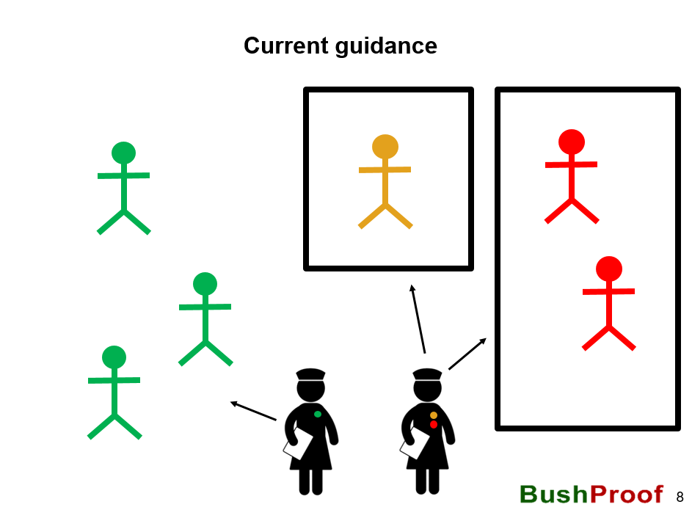

- The problem with this lies with asymptomatic and pre-symptomatic transmission. If a resident or staff member has no symptoms they can still (a) have COVID-19 and (b) be infectious to others.
- This transmission can happen from staff members to residents, or vice versa, or resident to resident.
- Also, there is the chance that someone who is symptomatic might actually not have COVID-19.
- In the example below, we show the categorisation of staff and residents by symptoms (shown by colour), while showing those who actually have the virus to be carrying a small red virus. So here we can see that we have one asymptomatic resident who is carrying the virus (categorised as green though since they have no symptoms), one asymptomatic staff member who is also carrying the virus who has been allocated to work in the green areas, and one symptomatic carrier of the virus (red). All can give transmit the virus to other residents / other staff members / inanimate objects if they don’t perform obsessive hand hygiene, use PPE and other protocols. It shows that screening and taking action only based on symptoms, will not stop the virus, and that asymptomatic carriers are a serious risk for spreading the virus if we do not have measures to stop this.
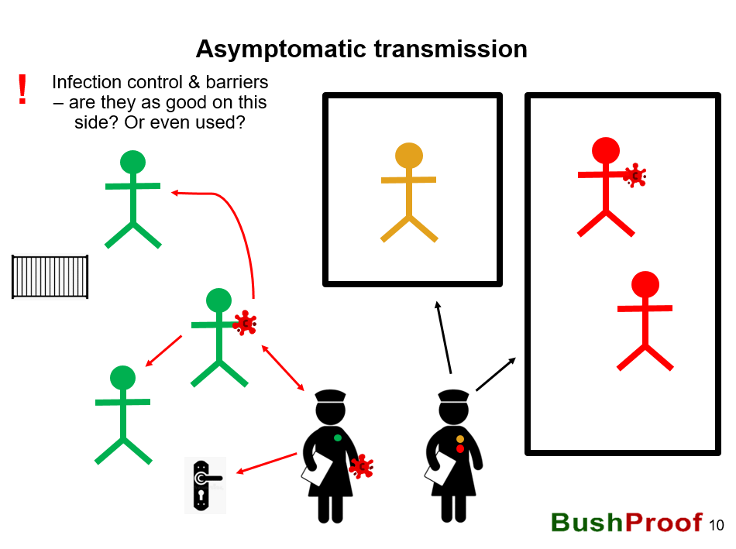

- If this is the case, how to stop it then? We therefore need to think of infection control in terms of barriers to transmission everywhere.
- This applies even for those people (staff and residents) who do not have symptoms.
- We also need to remember that the virus remains on objects. It’s not all about person to person transmission, actually it is as easy to transmit it via an object like a door handler or railing.
- In the example below, you can see some ideas for how to create those barriers – this includes hand hygiene every time you cross a zone, every time before and after you touch a high-touch object (like a door handle), by using PPE, and by minimising close contact. This is the basis of infection control outlined in this document.
